5 February 2001
PRESS RELEASE

Subject: Cruising with the Cranes 15K Road Race Results
A total of 55 individual and 15 relay teams participated in the first annual “Cruisin’ with the Cranes 15 k at the Bosque del Apache National Wildlife Refuge this Saturday. The Socorro Striders and Riders hosted the race, with the support of the Friends of the Bosque del Apache National Wildlife Refuge and raised money for the Education Transportation Fund, which helps New Mexico school districts with transportation costs for field trips to the Refuge.
In addition to several talented local athletes, the race also attracted a truly world class field. Leading the men’s race, Greg van Hest covered the 9.3 mile race in 45:44, at an average pace of under five minutes per mile. Van Hest finished 25th in the 2000 Olympic Marathon in Sydney and represents the Netherlands. Van Hest was challenged by Poland’s Kryzstof Baldyga in 46:16. Kryzstof’s wife, Renata Baldyga won the women’s division in 1:01:02. Leading the local athletes, Sandy Nolen and Kim Schaffer placed second and third in the women’s field. The local men were lead by Dave Lord.
Race director Cathy Pearce said “We were very pleased with the turnout today. The weather and the birds were beautiful, and the race offered something for everyone. We were really surprised by how popular the relay division was today.” Socorro was well represented with five relay teams, including the first local team, the Bubbly Bubblers (Lawrence Montano, Casey Spurgen, Mark Wheeler) in 1:19:13. Another Socorro team, “Two Guys and a Geezer” (Chris and Nick Sramak and Greg Ainsworth) placed first in the family team division.
For many of the race participants it was their first visit to the Bosque. Runner Rodger Sack from Albuquerque said “We spent a couple of hours driving around looking at the birds after the race - very impressive!! It was our first visit to the Bosque del Apache, but will definitely not be the last.” Pearce said, “the support of our local sponsors, the local Socorro Amateur Radio Association, and local law enforcement really helped us host a great event, they were wonderful.” Both the Friends of the Bosque and the Socorro Striders and Riders look forward to hosting the event next year.
The Cruisin’ with the Cranes 15 km is sponsored by the City of Socorro, Socorro Super 8 Motel, Socorro K-Bob’s Steakhouse, Brooks Sports, Merrill Lynch (Cheryl & Emerson Learn), Fleet Feet Sports, The Athletes Edge, Middle Rio Grande Realty, The Water and Ice Store, The Super Salve Company, and Martha’s Black Dog Restaurant.
Cruisin’ With the Cranes 15K
2001 New Mexico State 15k Championship
San Antonio, New Mexico
Results of Local Residents and Leaders

Last First Time Group Place Pace
van Hest Gregory 0:45:44 M25-29 1 1 04:54 (First Male)
Baldyga Krystoff 0:46:16 M25-29 2 2 04:58 (Second Male)
Broaddus Chris 0:51:10 M25-29 4 3 05:29 (NM Champion)
Otero Daniel 0:56:45 M40-44 10 1 06:05 (NM Masters Champion)
Baldyga Renata 1:01:02 F25-29 15 1 06:33 (First Female)
Leddy Patrice 1:13:58 F40-44 37 2 07:56 (NM Champion)
Nolen Sandy 1:07:52 F35-39 23 1 07:17 (First Socorro female)
Schaffer Kim 1:09:14 F35-39 25 2 07:26 (Second Socorro female)
Lord Dave 1:04:40 M30-34 18 2 06:56 (First Socorro male)
Higgs EP 1:28:04 M35-39 61 4 09:27 (Second Socorro male)
Yarger Fred 1:34:31 M45-49 67 9 10:08
Vaiza Shorty 1:22:45 M50-54 56 7 08:53
Cowboys Team 0:50:01 M team 3 1 05:22 (First team)
Bubbly Bubblers Team 1:19:13 M team 48 7 08:30 (First Socorro team)
Cheeseheads Team 1:31:10 F team 63 2 09:47
Isotopes Team 1:31:12 F team 64 3 09:47
2 Guys & a Geezer Team 1:10:22 family 32 1 07:33 (First family team)
Team Napier Team 1:27:08 family 60 2 09:21
Local athletes are in boldface.
About the Socorro Striders and Riders: The Socorro Striders and Riders (SS&R) is a local club of approximately 30 runners, triathletes, and cyclists. The primary focus on the club is the social, recreational, and health benefits of sport. The SS&R holds regular group runs and bicycle rides and holds a monthly business meeting and social gathering on the first Monday of each month. The SS&R is a member of several national organizations, including the Road Runners Club of America, the American Cycling Association, and USA Triathlon. For information, contact SS&R President Cathy Pearce at (505) 835-2507.
About the Friends of the Bosque: The Friends of the Bosque is a non-profit organization dedicated to the safeguarding and enhancing the habitats of the Bosque del Apache Wildlife Refuge and to providing a quality educational experience for visitors. In addition to the Education Transportation Fund, the Friends sponsor the Junior Duck Stamp Program in the State of New Mexico, conduct interpretive tours, a summer workshop series, training for Refuge volunteers, and product educational literature. The Friends, in concert with the Refuge and the City of Socorro, also organize the Festival of the Cranes.

[ Attached photographs are available electronic as *.jpg format. ]
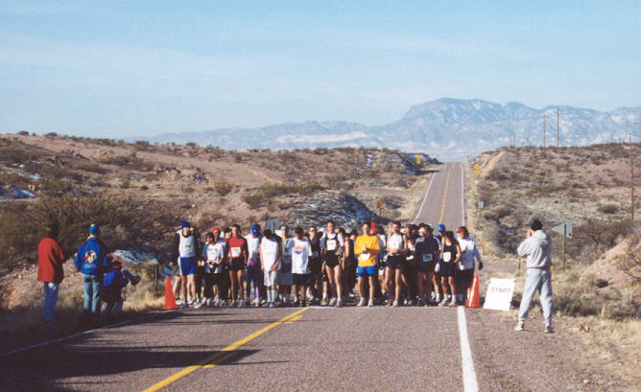
Athletes wait for the start of the Crusin' with the Cranes 15k Road Race.
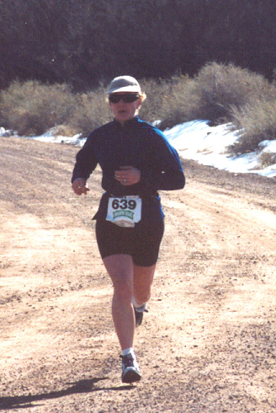
Sandy Nolen approaches the finish for second place in the Cruisin' with the Cranes race.
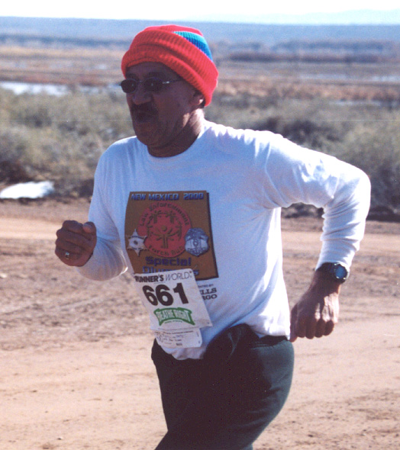
Local police officer Shorty Vaiza finished the challenging course in 1:22:45.

