April 1, 2001
PRESS RELEASE

Subject: Socorro Springs Brewing Company Winter ITT Results:

San Marcial 31 March 01– The Socorro Springs Brewing Company ITT Series concluded last Saturday with the fourth and final event. The 30 km bicycle race started and finished near San Marcial on New Mexico Highway One. Socorro athlete Terry Moore had the fastest time of the day for the women with a 54:43. For the men, David Wykoff won with a 43:20, averaging nearly 26 mph over the hilly route and setting a new course record. The fastest male local rider was Eric Pearce, in 47:34. Awards for the series were based on the riders combined time in two events. Local riders took six of the nine awards, with Sandy Nolen, Terry Moore, and Deborah Dennis sweeping the women’s prizes. In the open men, Christian Krueger and Marcos Alvarez took second and third respectively. For over-40 men, Eric Pearce took second overall.
The next SS&R event is Rivertrailz/San Marcial Time Trial, which will be held on 12 May 2001. This event will be part of the New Mexico Road Series, a 10 race state-wide bike racing series. The event will be 40 km (25 miles) in length for advanced riders and 20 km for beginners.

Socorro Springs Brewing Company ITT #3 (Local Results), San Marcial, 31-Mar-01 (b 30 km ITT):

Eric Pearce 47:34
Christian Krueger 49:13
Terry Moore 54:43
Marcus Alvarez 56:05
Sandy Nolen 56:29
Mike Dennis 58:19
About the Socorro Striders and Riders: The Socorro Striders and Riders (SS&R) is a local non-profit organization of approximately 30 runners, triathletes, and cyclists. The primary focus on the club is the social, recreational, and health benefits of sport. The club is open to individuals of all abilities. The SS&R holds regular group runs and bicycle rides and holds a monthly business meeting and social gathering on the first Monday of each month. The SS&R also organizes several local events, including the M-Mountain Duathlon, Socorro Triathlon, the Rivertrailz/San Marcial bicycle time trial, the Merry Mile, and the Cruisin’ with the Cranes 15k. The SS&R is a member of several national organizations, including the Road Runners Club of America, the American Cycling Association, and USA Triathlon. For information, contact SS&R President Cathy Pearce at (505) 835-2507.

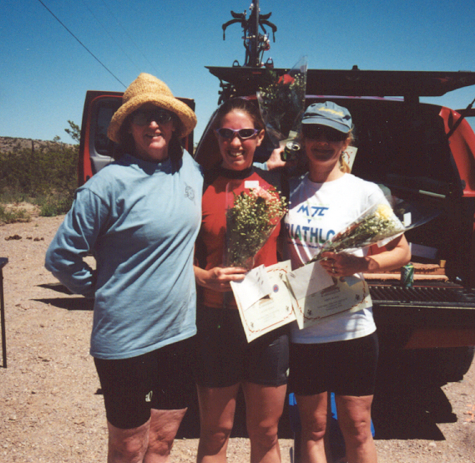
Socorro Women Sweep the Awards in the Socorro Springs Brewing Company Time Trial Series (from left to right, Deborah Dennis, Terry Moore, and Sandy Nolen).

