SH₃ Hash Trash

Vol. 4, No. 1 Hash No. 37
Hash Date: 19 January 2006
Scribe: Nuclear Semen
Hare(s): Nuclear Semen & Alcatramp

Well…! If you missed this hash, you really MISSED it!!! It was probably the most memorable ending to a hash that the M Mounters have ever had (and that may be understating things)!!! The first ever Over-the-Hill Hash (in honor of C Major Ass’s birthday) began at the El Matador Lounge (the brewpub has just gotten too crowded and noisy!) on a mild winter evening. Present were yours truly, Nuclear Semen (hare for sure!); Alcatramp (virgin co-hare for sure!); Virtual Clinton; Nothing’s Hung Like A Deere (sans his other half… supposedly “under the weather”… not like Second Hand to miss a hash!); C Major Ass (BIRTHDAY GIRL!); and Giggles (his last hash with the M Mounters for a while… something about finishing school??… yeah, right!). Tagging along were Just Seth and Just Fish. And, dear to the heart of any hasher, there were three virgins – Virgin Ligia (coming for C Major); Virgin Colin (Padre VLAAA made him come); and Virgin Brad (also coming for Padre VLAAA). And just where was Padre VLAAA??? That’s a down-down for him next time (making virgins come without being there… not a bad trick, though!).
In honor of her birthday, C Major was made to wear a birthday hat (she looked so pretty in her SpongeBob SquarePants hat!!!… it just wouldn’t have been the same in a Cinderella hat!). Giggles was a bit hungry before the start of the hash; so, he just had to have a bite to eat (seemed like a great time for the hares to leave). Thus, given a fifteen-minute head start, Hares Nuclear and Alcatramp headed into the darkness. Meanwhile… back in the lounge… the pack finished off their drinks (and food in Giggles’s case), counting down the minutes until they could head out in pursuit of the hares.
Stepping out the front door of the El Camino (a.k.a. El Matador), the pack encountered its first check. True trail was found to cross (why do I even bother to say it…) California Street towards the east. The trail continued east before turning north on 6th Street. A check was encountered at the entrance to WalMart before true trail was found, still heading north. The trail then turned west and back across California Street at College Avenue. The pack missed the first pack check (photo op) in front of the Tastee Freeze (not terribly observant, this pack!), continuing west on College. Again at the corner with Franklin/El Camino Real, another check was found. True trail continued to head west. Crossing Leroy, the trail headed from a check there onto the New Mexico Tech campus and swung around to the north between Weir Hall and the library. North of Weir the trail headed west and, eventually, around Speare Hall. Making their way to the fountain, the pack found the next pack check (finally!!).

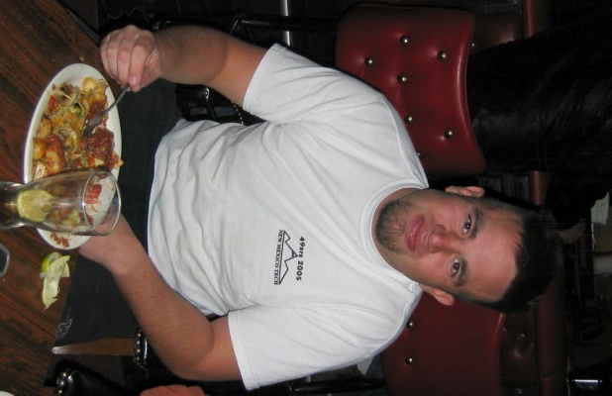

Just too hungry to wait… eh, Giggles??

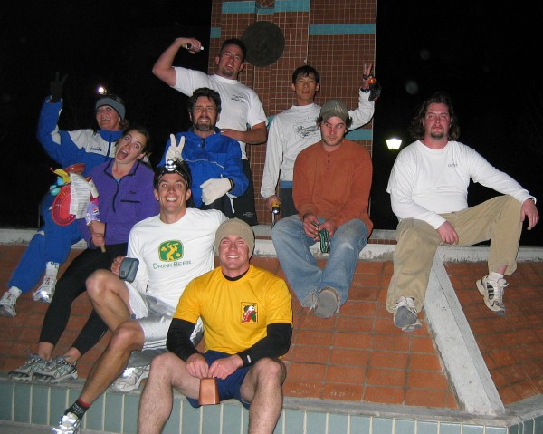
M Mounters at Tech fountain… hey,… who’s holding the camera??

From the pack check, true trail headed west along the south side of Workman Hall and out to Olive Street. There, the trail headed south, arriving at a turkey-eagle (T-E) split at the corner to Tech Hill. The eagle trail headed up Tech Hill on South Drive until it reached the top and turned south. At the end of the street, the eagle trail headed down the hill onto Romero Street (going by what was once married student housing). Cutting back over to the Olive, the eagle trail rejoined the turkey trail. Meanwhile, the turkey trail just headed south to where the eagle trail came out from student housing. Surprisingly, Nothing actually missed the T-E split, making up a lot of distance on the hares (“I didn’t see it,” he said… likely excuse!).
After the trails joined, true trail headed down to Neel Avenue and took a turn south at Goad. The trail passed by Nothing’s house (where a false BN was marked). Again, the pack failed to see the pack check nearby (no wonder there weren’t many photos from this run!!). The trail continued south to Western and then up the hill to the first true BN at Alcatramp’s house. Hares Nuclear and Alcatramp came out looking for the pack, which missed the BN mark on the driveway. The “turkeys” arrived first with the “eagles” about five minutes behind. The pack was treated to beer, water, goodies, and party hats. While the pack gorged, C Major serenaded them on Alcatramp’s piano. Virgin Ligia took to playing with Alcatramp’s big pussy (CAT, “gutter-brains”!!!).

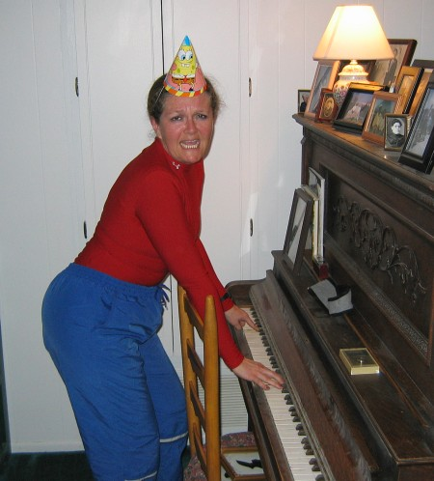

C Major Ass banging on the keys… yeah, SpongeBob!

After what seemed like forever, the appointed time came for the hares to depart. Given a ten-minute head start, they headed off… but left behind a very important item. Hare Alcatramp realized she had left her copy of the trail map folded up on the counter. Hare Nuclear responded, “They won’t notice it.” So on they went down Western back to Neel.
WELL!!… Here’s where the hash took a “sharp detour” to the dark side!!! Even the best-laid plans sometime get found. Opening up a folded piece of paper on Alcatramp’s kitchen counter, Virtual recognized the plan for the evening’s trail!!! Without hesitation, he announced his discovery to the pack… and the GAME was on! Almost unanimously (except for Just Seth who wasn’t present for the discussion) the pack voted to become SHORT-CUTTING BASTARDS (SCB) and beat the hares to the next (and final) BN! Thus, the pack headed off with poor Just Seth in the lead.
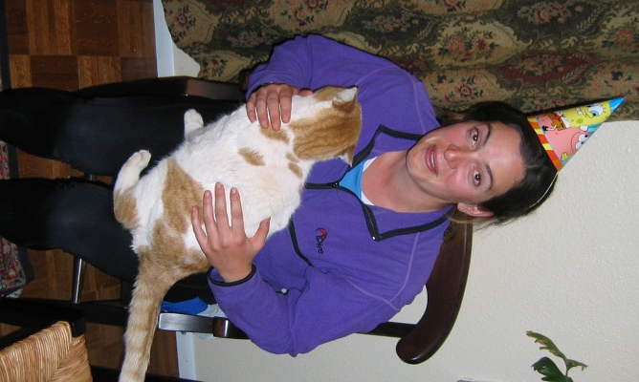

Virgin Ligia pets Alcatramp’s pussy!

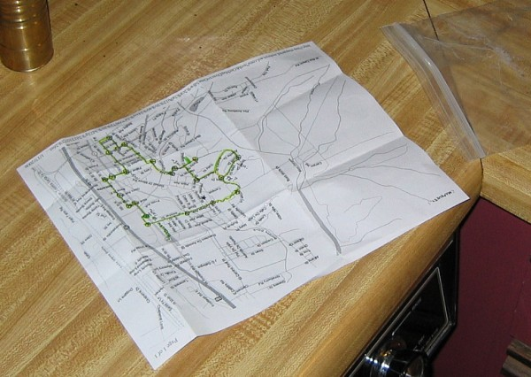

THE MAP!!!!!!
Just Seth began to follow true trail - oblivious to what the rest of the pack were planning. He soon realized that he was all alone and that the pack no longer appeared to be following him. HATS OFF to Just Seth who managed to follow the remaining trail BY HIMSELF!!! True trail headed southeast on Neel to a pack check at Bhasker’s clinic and then east towards the plaza on Fisher Avenue. The trail then cut south on Eaton west of Torres Elementary School to McCutcheon Street. At McCutcheon, the trail headed east again to the County Courthouse to another pack check. From there it headed through the children’s playground east to California. Crossing California, true trail headed through First State Bank’s drive-thru to the Loma Theater to another pack check. From there it headed north on 6th Street, cutting west to the entrance of the Roadrunner (another false BN). As Hares Nuclear and Alcatramp again crossed California at the Ace Hardware they were greeted by Virtual Clinton, holding “THE MAP!!!!”
With that, everyone adjourned to the El Matador (some of the pack were already inside) for Religion.

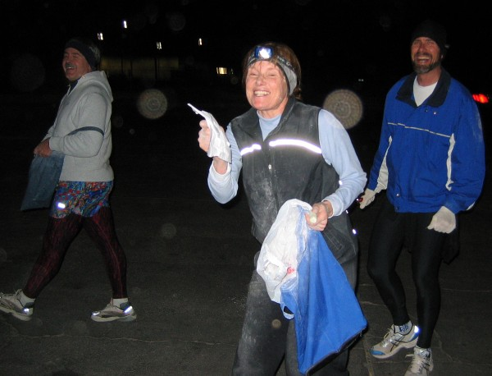
CAUGHT!! (Damn those SCBs!)

With beer ordered and C Major’s birthday cake on the table (thanks to Second Hand and her trusty delivery man, C Major’s son), Virtual called Religion to order. The hares were really roasted for not having enough copies of the map and not using enough chalk (there wasn’t any flour or chalk left in my bag!!!). But they were especially chastised for getting caught! Hares Nuclear and Alcatramp drank their down-down. Virtual called for “Crimes on Trail” next. There was the usual litany of people using wanker names, wearing “R” apparel, saying the “M” word, and wearing hats during Religion. Appropriate down-downs were assessed. About ten or fifteen minutes after the arrival of the hares, Just Seth arrived (remember him?… he’s the only person to follow true trail back to the El Matador… yeah, the one the pack ABANDONED!).

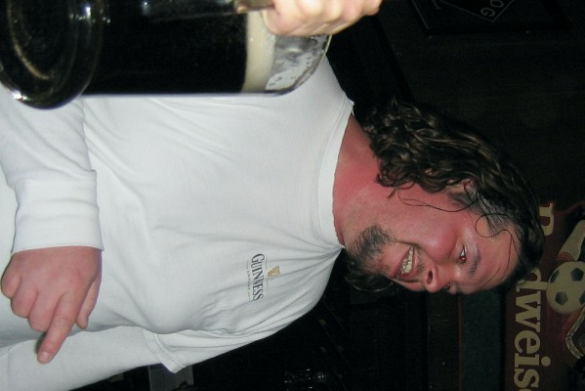

Just Seth… the ONLY non-SCB!!!
Religion continued with a toast to the virgins (though they be virgins no longer…) and those who made them come (only one of which were present… C Major!).

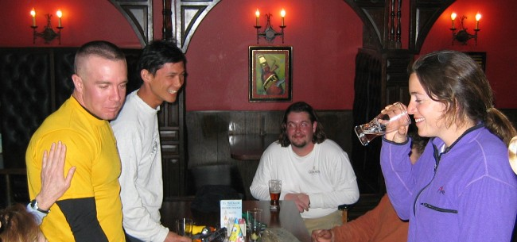
The virgins down-down!!

“Blood on Trail” honors went to C Major for twisting her ankle (couldn’t tell by the photo!). Nothing and Just Seth were given down-downs for being FRBs! In addition, Just Seth received a down-down for being DFL (really, now… that’s pretty harsh for THE ONLY PERSON TO FOLLOW TRUE TRAIL!!!). With no names to pass out (speaking of which,… where is the Naming Hat???), Nothing led the group in the Hasher’s Prayer and Religion was adjourned.
The next hash was scheduled for 9 February, starting at the El Matador. The theme is Valentine’s Day; so, wear pink or have your heart on. No one stepped up to hare; so,… (what a great opportunity for someone to prove themselves Mighty Hare!!!).

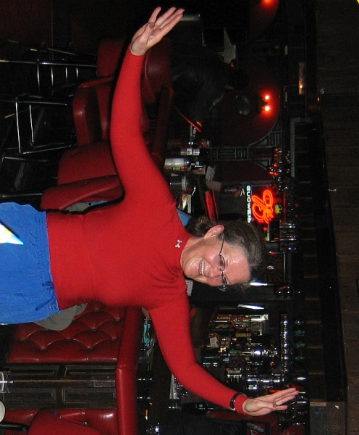
Birthday Girl, C Major, showing no ill effects from her twisted ankle!?!?

ON ON!!!

Next Hash Date: 9 February 2006 (Valentine Hash… wear pink or have your heart on!!)
Next Hash Hare(s): TBD

