SH₃ Hash Trash

Vol. 2, No. 13 Hash No. 23
Hash Date: 9 December 2004
Scribe: Nuclear Semen
Hare(s): Nothing’s Hung Like A Deere

For those NOT afraid to wear a dress in public, the 2nd annual Little Red Dress Hash was an enjoyable experience. Down-downs are in order for all the rest of you who failed to make an appearance. The Socorro Springs Brewery was packed, and plenty of heads turned as the Socorro Hash House Harriers took their seats. On hand were yours truly (Nuclear Semen) (in a lame excuse for a “dress”); Virtual Clinton (carrying extra dresses for those without… wonder what else is in his closet?); Nothing’s Hung Like A Deere (hare extraordinaire) (WOW!! with a wig, he might give the ladies some real competition!); Second Hand Dyke (I think she must wear the pants in the family!); Rapid Shitty Anal Cyst (for a moment it looked like he was going to need one of Virtual’s spare dresses); Just Addy (in a return engagement…); and Just Diana (I think she’s been avoiding our company BECAUSE SHE DIDN’T WANT TO GET NAMED!!!). Finally, the naming hat and hashit had returned… and guess who was going to pay for it??
After giving the pack instructions to take pictures at every pack check, Hare Nothing headed into the night. With a 15-minute delay, the pack soon followed without a chalk talk (with all these veterans… who needed one?). After some wandering, Virtual found true trail heading south towards the Plaza. Passing Papa Don’t Preach’s place (a regular “no-show’r” lately), the FRB’s headed south past the Cap, picking up trail about a block away. From there, the trail headed west past the county courthouse to a check. True trail was picked up heading north back to the Plaza and back to the… Cap??? After some intense cogitation (and some serious thinking, too), Nuclear suggested that the pack had circled the wrong way from the Cap. The pack went back to the check and reversed direction, heading east. Nuclear picked up true trail heading towards California Street (couldn’t be a true Socorro hash without crossing the “drago maino” at least once!). Heading across California, the trail went east on Manzanares Street, turned and headed north in a zigzag pattern. Passing through a garage parking lot where the workers were working late (they left the lights on), the trail continued north until reaching the first pack check (well… actually the second as Hare Nothing pointed out to the pack at the first beer stop) in the WalMart parking lot. The on-duty security guard quickly came over to check out the pack and determined that it wasn’t a bunch of anti-WalMart crazies intent on vandalizing the premises. A departing worker graciously took the pack’s picture for posterity (and everyone’s general amusement!). With a decent image in memory, the pack went back to the business of pursuing the elusive hare.

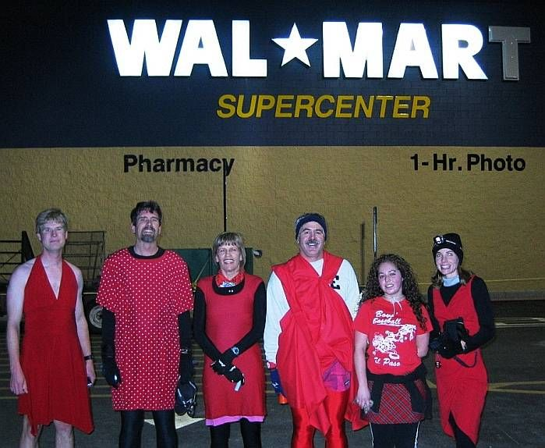
Surely a group of evil eco-terrorists!!

After a couple miscues, the pack finally found true trail heading back out to California Street. Getting plenty of rude comments from passersby, the pack headed north, eventually crossing it and finally winding up at the next pack check in front of Smith’s. An amused patron gladly took the pack’s picture; and, with camera in hand, the pack followed true trail south through the back parking lots of nearly every business along the west side of California Street. Finally, after what seemed like an eternity pounding the pavement, the pack reached the first BN of the night at the Matador Lounge (and not too soon for Rapid City who was about to freeze his… well, you get the picture). Little did the pack realize all that the hare had been through in getting to the BN himself…

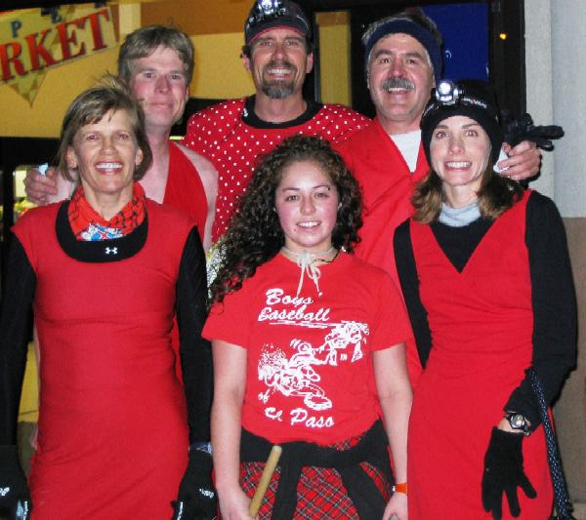
Okay, everybody… huddle up!

Nothing proceeded to tell the pack of the terrible ordeals that had befallen him while laying out the trail (his story was almost good enough to distract the pack from drinking some brewski!!). Nothing told of how he was watching as the pack passed through the WalMart parking lot when the city constabulary (not one… but two patrol cars!) arrived at the Lounge. Giving Nothing a quick look over, the police entered the premises. Apparently, the police had been called about a strange dude wearing a red dress. Leaving, Nothing asked one of the policemen if they were looking for him. The policeman answered in the affirmative, whereupon Nothing proceeded to tell him about hashing. Seemingly satisfied, the police departed. Nothing also related how the security guard at WalMart nearly called the police on him as he started laying trail in front of the store (you just looked too much like an eco-terrorist, Nothing…). Nothing asked the pack how many pictures they had taken. When told only “two” (WalMart and Smith’s), he said that there was one at the Socorro County Courthouse (obviously missed while the pack ran in circles…).
As luck would have it, the Matador was a busy place; and it wasn’t long before things started happening. Father Snowball (at his last hash as a Socorro Hash House Harrier) and Miz Schaffer, Can I Go To The Bathroom (that’s, “may I go to the bathroom”) joined the pack (a bit late aren’t we???). Father proceeded to change into something more comfortable (courtesy of Virtual Clinton) while the rest of the pack took a well-deserved break. Nothing was again accosted – this time by a lady at the bar who offered him money for a table dance (I wonder what she would have done for a lap dance???). Not to be outdone, Rapid Shitty was accosted by a male patron (a real tit pincher!). Obviously, things were starting to get rowdy; so the pack sang a song and Nothing headed back into the night (without a police escort!).
After giving the hare a ten-minute head start, the pack headed back out into the cold. True trail headed back north along California Street but took a left at the Circle K and headed west towards New Mexico Tech. In a roundabout fashion (and through some great shiggy in the dark!), the trail ended up on campus where a pack check was encountered at the entrance to the gym. Coercing a student into taking a picture, the pack posed for what would be the final pack check of the night.

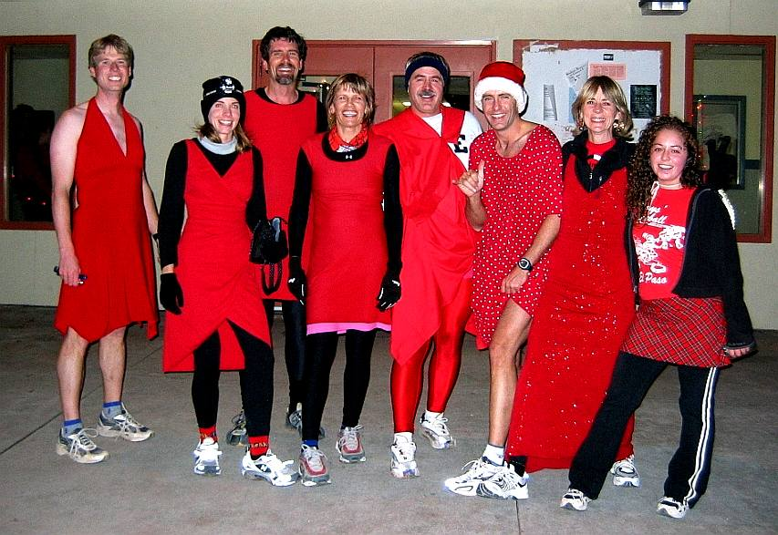
And the winner of the cutest legs contest is…

Proceeding south from the gym towards the athletic fields, true trail turned east and started heading down School of Mines past Virtual’s abode. Nuclear picked up true trail as it headed off on a side street and turned back west up an alley, eventually leading to the final BN at Virtual’s house (and he didn’t even know that he was having a party!). Some brews were had and songs were sung (including a first grade tune led by Miz Schaffer… shows the level of intelligence of this pack). Nothing posed for some mug shots (since no one had to go bail him out of jail!). As thoughts turned to naming Just Diana, questions began to fly about her home, her interests, and her potentially “juicy” past. On-In was declared and the gang headed back to the brewpub.
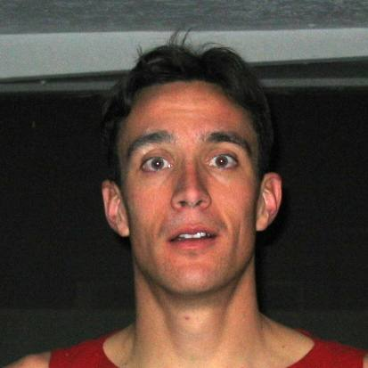

FORD, EPHRAIM 9 DEC 2004
000000000000000
SOCORRO PD SOCORRO NM

A Deere caught in the headlights!!!

Beer and food were ordered while the “ladies” ensured that their gowns were properly adjusted. Nuclear delegated the duty of Religious Advisor to Nothing, who proceeded to be roasted as hare. With a rousing chorus of Shitty Trail, Nothing drank his first down-down. Crimes on trail were exposed, leaving everyone standing for a “communal” down-down (well… no one’s perfect!). Finally, the reason for our existence had arrived – to name Just Diana!!! A more serious interrogation of Just Diana was conducted. The name of her dog proved to be the “gem” of the evening – Sandy Vagina!!! [It’s still hard for me, Nuclear Semen, to imagine anyone providing such a golden opportunity on a silver platter.] Just Diana was asked to leave the room while the pack decided her fate…
Lots of good names were proposed – El Paso Gasso and Belching Vagina (for her unladylike performance at the last BN), Immaculate Infection, Loves To Be Poked (based on her penchant for body piercings… where did you say that one was?), and, of course, her dog’s name Sandy Vagina. After much thought, the pack knew that they couldn’t name her after her dog – why she must like that name or she wouldn’t have named her dog that. But, what about a name synonymous with her dog’s name??? With that thought, the pack nearly unanimously agreed upon GRITTY GASH!!! Gritty (a.k.a. Just Diana) was invited to return to the table and learn of her fate

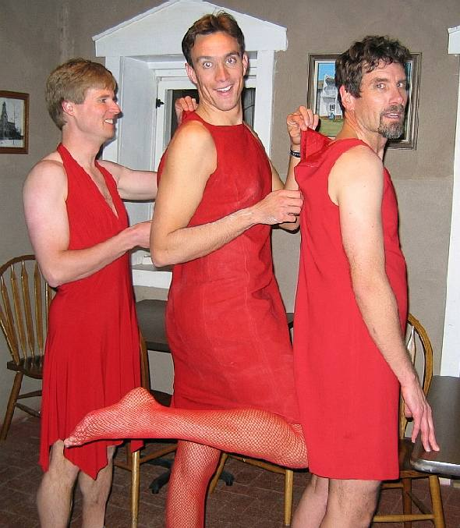

The “ladies” adjusting their gowns…

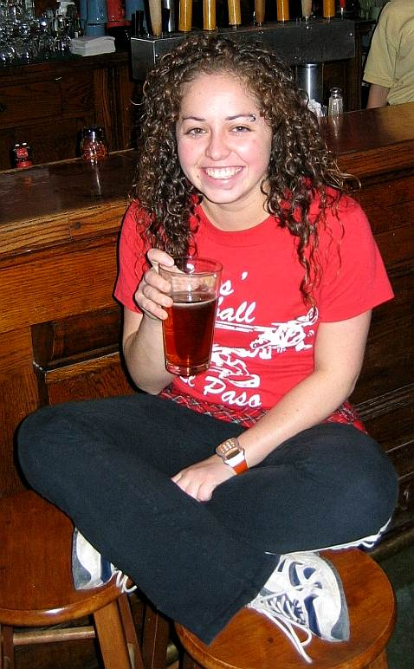

I give you… Gritty Gash!!!!
Somewhere in all of this, Nothing decided that he didn’t like his gown and wanted to try on Miz Schaffer’s, which actually belonged to her daughter (Sorry, Brittany!!!).

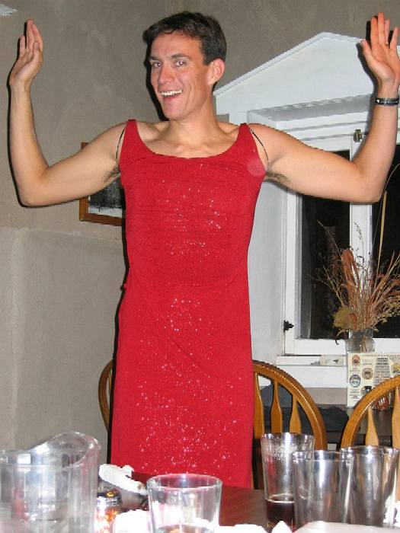

Miz Nothing (Hey, shave those ‘pits!!)

As it was Father Snowball’s last hash before moving to Silver City, we toasted our beloved (and much abused) comrade. But he couldn’t be allowed to get away that easy; so, he was charged with “fathering” a new hash group in Silver City. The pack promised to “come” down in a few months to see how he was doing with his assignment (and he thought he had finished school!). With best wishes, we bid Father Snowball farewell (Good Luck, Father!!!).
With that, the Hasher’s Prayer was said and a date and hares were set for the next hash in January.

ON ON!!!

Next Hash Date: 13 January 2005 (the SECOND THURSDAY!!)
Next Hash Hare(s): Miz Schaffer, Can I Go To The Bathroom and Virtual Clinton

