SH₃ Hash Trash

Vol. 2, No. 11 Hash No. 21
Hash Date: 28 October 2004
Scribe: Nuclear Semen
Hare(s): Padre VLA & Wet And Hairy Banana Fairy

Well, it’s official! We’re legal! Now we can drink in public (although it never stopped us before)!!! To all you ghouls and ’goyles out there who were too lazy to dig up a costume and join us for our annual Halloween Hash, you missed a great one. Ah, the stories we could tell… (and will tell)
In the back courtyard of the Soccoro Springs Brewery (to avoid the stares and glares of the remaining clientele), the brave and hardy (fearless of the denizens of the night) gathered. Present were Nuclear Semen (yours truly) (a vampire with a poor makeup job); Virtual Clinton (another Dracula wanna-be); Padre VLA (Mr. Metallica) (it’s a wonder that he wasn’t “Mr. Sliced Meat” with that outfit!); Wet And Hairy Banana Fairy (a mini-VLA, looking for his Mother Ship); Nothing’s Hung Like A Deere (a freshly neutered mongrel with his “don’t scratch, don’t tell” collar) (Second Hand wouldn’t tell either!) [This was probably the best outfit of the night!]; Second Hand Dyke (a great Barbie look-alike in vinyl bell-bottom pants that reminded Nuclear of that episode of Friends where Ross wears leather pants) (This was to provide the highlight of the evening…) [I knew she was too hot to handle!]; Rapid Shitty Anal Cyst (the Black Ghost who needed a seeing-eye dog); Just Rheda (who was enjoying her last hash with a “wanker” name) (as Barbie’s mother who, with “little Barbie,” would have an unforgettable and “not-repeatable-in-front-of-the-children” experience); and Just Nico (Bacchus with a Teenage Mutant Ninja Turtle fetish). Rounding out the cast was Hell’s Fairy, in a return engagement as a “pick-up” hasher (It was a pleasure to meet his “better half” who didn’t seem to be offended by “Religion.”).
With costumes still “fresh,” it was time for a “photo op.” The waitress (somewhat reluctantly) snapped a picture of the entire gang (probably hoping we would get lost and never come back). Nothing then took a picture of the hares, Padre VLA and Wet And Hairy, prior to their departure. Nothing and Nuclear shared duty as “Father Time” while the pack ensured that no beer was wasted.

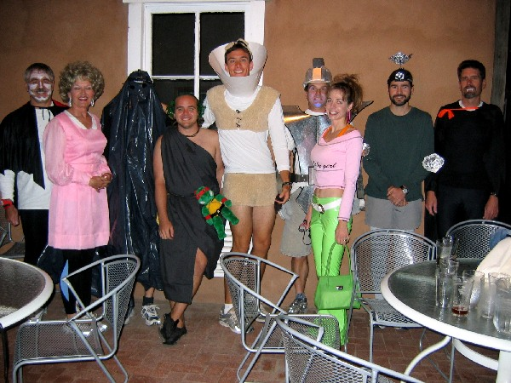
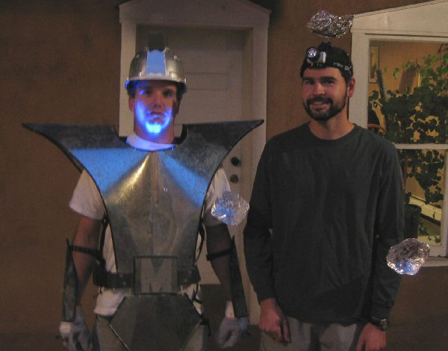
Looks like the gate was open at the insane asylum!

The Hares! (You have to say this with feeling like, “The Bears!” on SNL!)

After a generous 15-minute head start, the pack ventured into the night for a brief (I mean “brief” as there were no virgins!) chalk talk by Virtual Clinton before starting to scout out trails. Virtual found true trail heading east past the Garcia Opera House and across California Street (How many times did we end up crossing California Street???). Circling around and then south, the pack encountered a check under the streetlight at the corner by Cooney’s Liquor. Dutifully standing on the check while the FRB’s went in search of true trail, a white sedan stopped and asked our fine ladies what they were offering and for how much. Yes, Second Hand and Just Rheda were propositioned!!!!! (And people say that Wal-Mart won’t bring new business to Socorro!) Fortunately (or maybe unfortunately?) neither was up for such an offer and the car headed off up California Street. Soon after (and to the relief of Second Hand and Just Rheda), “ON-ON” was heard and the pack headed off in the direction of Clarke Field. As true trail headed back across California Street (AGAIN!) towards the west, rumors were flying amongst the pack as to the real reason Second Hand and Just Rheda were dressed as they were (I wonder…). Continuing on a zigzag course, the trail worked back to the north and spiraled into the Capitol Bar for the first BN of the evening.
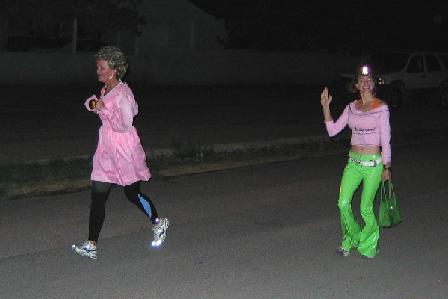

Pretty in pink. Lovely enough to pick up!!

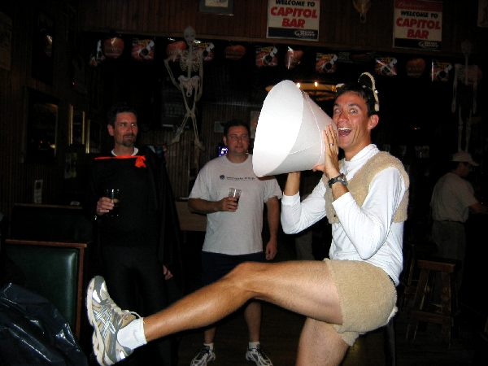
Once at the “Cap,” everyone heard the story of our own “ladies of the night” over a cold one. Nuclear informed Second Hand that she should have told the gentlemen, “I don’t come cheap, boys!” If that wasn’t enough to create a stir, the man at the end of the bar (yeah, the one with the glasses in the blue jacket) kept eying Nothing (I thought you’d been neutered, Nothing?). If it hadn’t been about time to head back out on trail, Nothing might have received his own proposition! Meanwhile, Rapid Shitty got some fresh air by removing his “bag” (You looked better with it on!). A quick chorus led by Nothing signaled the imminent departure of the “monster” crew.

Nothing leading the pack in song at the “Cap!”

With a 10-minute head start, the hares led the pack west across the gazebo and up to Neal Street. The quick eyes of Nuclear averted the pack heading in the wrong direction with true trail heading towards New Mexico Tech. With a few howls (and not for the nearly full moon) outside Papa Don’t Preach’s house, the pack encountered a YBF. Carefully retracing its way back along Neal Street (after failing to read the “clue” provided by the hares about “tutus”), the pack found true trail near the BLM, heading around behind the dance studio. It wasn’t far from there to the next BN in Wet And Hairy’s backyard. In keeping with the mood, dry ice steamed away, chilling the brew, and “glow sticks” provided a hint of light to drink by. The group’s departure was delayed while we got Wet And Hairy’s dog into the house (Sorry about that!).
Having given the hares another 10-minute head start, the pack was off again in hot pursuit - east towards the Plaza. Cutting across School of Mines Road, true trail continued east and then took a left to cut through the courtyard of San Miguel Church (Yeahhhh, God!!!!). The pack followed the trail heading north and might have caught the hares if they had gone east towards Ace Hardware at the first road. But Nuclear (Damn those keen eyes!) spied the trail heading up onto the ditch bank. True trail continued for a short distance north on the ditch bank before heading east on a very muddy (PERFECT SHIGGY!!) road, which eventually came out behind Ace Hardware. More than one (including yours truly!) hound succumbed to a mud hole. Tracking back north along California Street, the pack was fooled into thinking that there would be a BN at the Matador Lounge. An extra trail mark left by the hares sent Nuclear and Virtual around the back. Fortunately, the true trail mark (aimed across California Street) was found; and the pack again headed across California Street and south. The final BN of the evening was found at the entrance to the Roadrunner Lounge. Inside, the hares were waiting with cold brew for the crew.

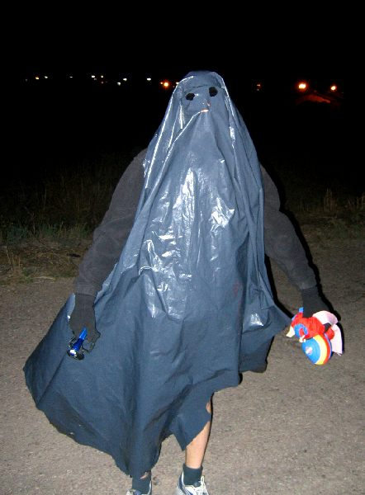
The Black Ghost? Or maybe just another trash bag blown in by the wind!!

After eating up most of the popcorn and putting back a few, “ON-IN” was declared and everyone filed out to head back to the brewpub. Back at the brewpub, food and drink were ordered. Hell’s Fairy’s better half joined the gang with their two young sons. Nuclear Semen filled in as Religious Advisor and the hash was trashed, starting with the hares. An appropriate down-down was given to the hares with the singing of “S-H-I-T-T-Y T-R-A-I-L” (and my shoes looked like it, too)! Next, crimes on trail were addressed with everyone found guilty of either the use of “wanker” names or other crimes. Everyone took a down-down!
The grand finale finally arrived with the naming of Just Rheda. Just Rheda was asked to step out (not outside!) while the pack cogitated on her “fate.” Names like “The Thighs Of Texas Are Upon You,” “Just Like Beef,” and “Kiss My Grits” were offered up. With a vote, the pack deemed that Just Rheda should be named Just Like Beef!!!! The Pack had spoken. Just Like Beef was invited to return and hear the news.

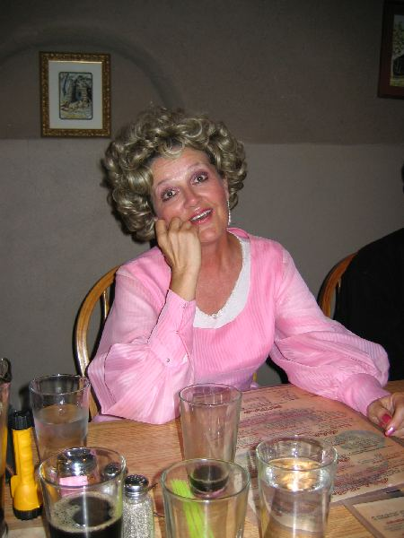
JLB upon hearing the “good” news!!!

Unfortunately, the name didn’t last very long (especially after Just Like Beef complained that she didn’t get a raunchy enough name) as Nothing’s Hung Like A Deere piped up with “C Major Ass.” In a unanimous recount (faster than the election of 2000!), Just Like Beef was renamed C MAJOR ASS!!
With business complete, Nothing led the group in the Hasher’s Prayer and Religion was adjourned. But the fun was not over yet! With the arrival of the food, another great “photo op” presented itself. Never missing an opportunity to take things to a lower level… Well… , see for yourself…

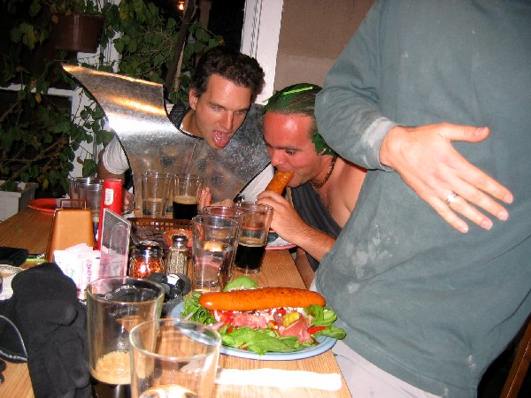
Phallic loaves!!!

The next hash will be Saturday, the 13th of November, with our “city slicker” relatives up north invited. A new name for the group was also discussed – “M Mount’ers.” Nuclear Semen will try to provide some logos to go with this moniker. See ya’ll round, ya’ hear!!!

ON ON!!!

Next Hash Date: 13 November 2004
Next Hash Hare(s): Rapid Shitty Anal Cysts and Padre VLA

