SH₃ Hash Trash

Vol. 2, No. 12 Hash No. 22
Hash Date: 13 November 2004
Scribe: Nothing’s Hung Like A Deere (w/ ghost scribe Nuclear Semen)
Hare(s): Padre VLA & Rapid Shitty Anal Cyst

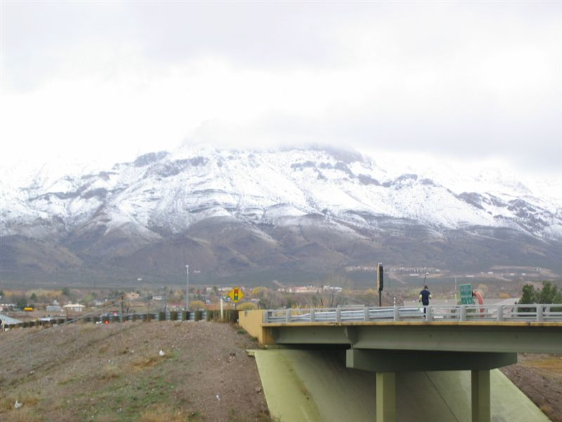
A great Socorro day (for a hash)!!!

Catch 22… With it having rained cats and dogs (at least the “dogs” part is correct), it only made sense to show up for a little romp in the mud for our 22nd hash. Of course, being Socorro, the dogs wandered around town before showing up, especially Father Snowball (late!) and Virtual Clinton (really late!! and dressed like a creepy ninja… one hash too late, Virtual!). It didn’t matter, though, as the pack filled the time fielding questions from brewpub patrons about our ill intentions (sometimes telling the truth… and sometimes lying that we were a sidewalk chalk artist group!).
Present for the gathering were Virtual Clinton; Father Snowball; Nothing’s Hung Like A Deere; Second Hand Dyke; Miz Schaeffer, Can I Go To The Bathroom; Seven Inches Shy; Padre VLAAAAA (Hare 1); and Rapid Shitty Anal Cyst (Hare 2). Rounding out the pack were Just Colin (a 5-timer… what shall we call him???), Just Nico, and Virgin Kristen (Just Nico’s sister… eewwww, her brother made her come… ya’ll from Arkansas???) [Was Father keeping his eyes (and hands) off her? – Nuclear]. One thing, no Albuquerque Hashers showed up (and we specifically had a Saturday hash for them!). And what is it about our weather for these “inter” hashes? Maybe they had enough from the last hash - one full of rain, lightning, and hail. Also, as is becoming habit, Just Diana was a no-show, which meant our naming hat and hash shit were unavailable for the day’s festivities (is she afraid of getting named?).
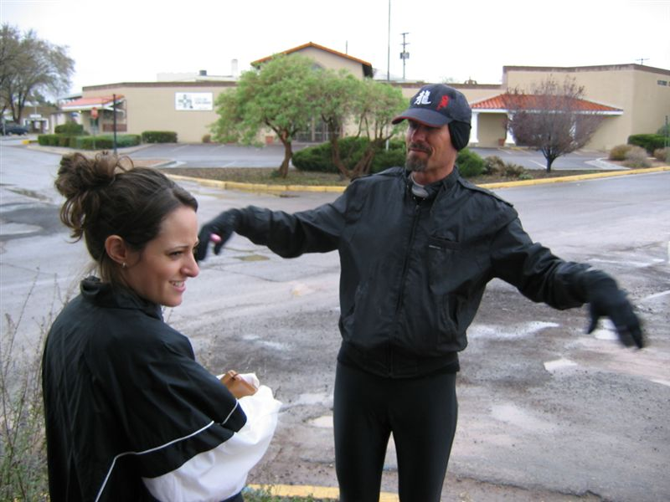
After giving the hares time to slog ahead, Virtual led Virgin Kristin outside for the chalk talk. We’re not sure he made a good impression…

That creepy ninja in the baseball cap!

In short order, Just Nico spotted true trail and the pack was off, heading south from the pub past Papa Don’t Preach’s shop (but not close enough to mark it) and across California Street. As the pack neared the highway, many began dreading the “crawl” through the culvert (amazing how a couple times through it in the past brings panic to the hearts of even seasoned veterans). Fortunately (rats!!!), a Turkey-Eagle (T-E) split was encountered that headed back north. As everyone took the Eagle route (gutsy bastards!), the hounds found themselves running along the frontage road the ENTIRE way to the I25 overpass at the north end of Socorro. Naturally, the pack spread out with “brother-sister” bringing up the rear (those DFL’rs). Of course, by this time, the pack had run through enough mud along the ditches that everyone was pretty wiped out and covered in shiggy. A few pitied Virgin Kristen’s “virgin” white running shoes (but not much!). But all were taken aback by Just Nico’s barefoot trek through the shiggy and along the road.

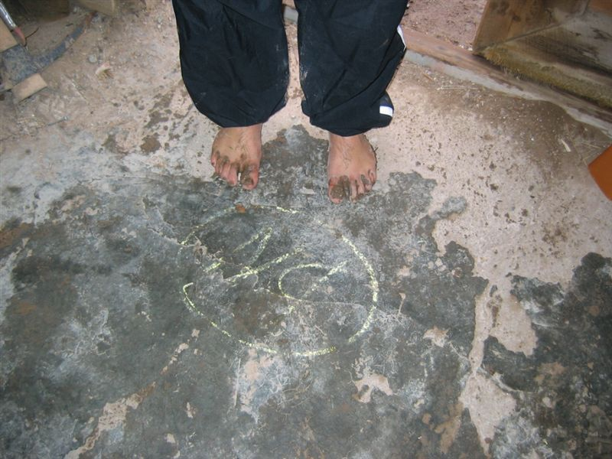
What? Couldn’t afford a pair of shoes??

As most of the pack crossed the overpass and headed back north towards Padre VLA’s house, where there was eventually a BN; Nothing waited atop the overpass and observed some Short Cutting Bastards doing their thing (pictures never lie!!!!). Just Nico (barefooted, to boot… or not to boot in this case) and Virgin Kristen CUT ACROSS THE HIGHWAY! Surely a down-down would be in order for this later (although one has to respect their gutsy-ness… or maybe their idiocy).

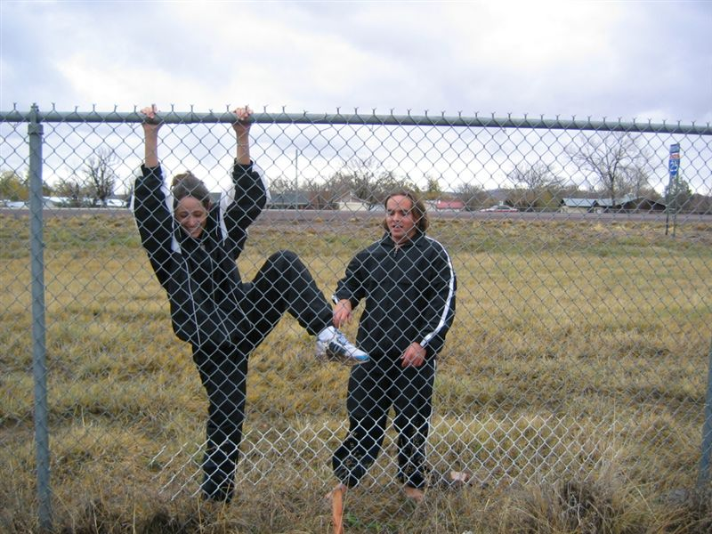
Some Short Cutting Bastards caught in the act!

Finally, the entire pack reached the BN and enjoyed the cozy little shack that Padre calls his own. Supplied with copious amounts of beer and food, all began to get relaxed and in good spirits (better, yet… “get good spirits in”). In fact, after admiring the large license plate collection, most started singing along with Miz Schaeffer’s TootyTa song. It may have been a low point for the hash, but everyone sure enjoyed it.

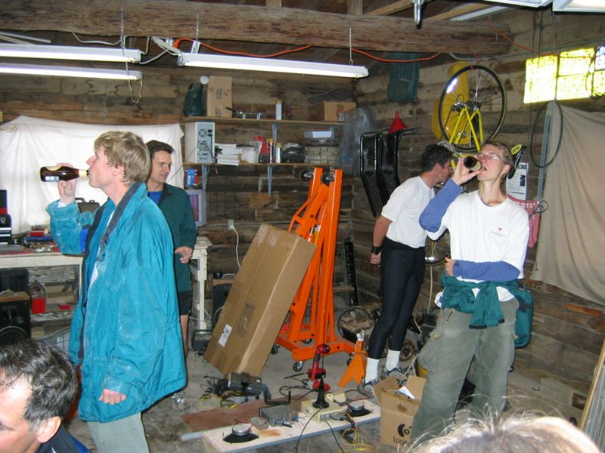
Interesting décor, Padre?

Back on trail, the pack crossed California once again and ran through various neighborhoods there. Encountering another T-E, the pack split with the tired “brother-sister” duo, the beer-foam-bloated Father Snowball (was that the only reason?), and Nothing taking the short route, beating all to the 2nd BN. It was at the 2nd BN (well… actually the house next door) that Father Snowball decided to make acquaintances with (and make an offering of some beer to) a large, and ferocious-looking, dog on a chain. Everyone assumed he knew this dog (but not in the biblical sense!) - that is, until its owner came out and wanted to know what the hell was going on. The group engaged in some more singing, some more drinking, and some more scraping the shiggy off their feet (although, what was the point?? more shiggy was sure to come).
The last leg of the hash was, like all the rest, full of shiggy!! Traveling along the ditch banks, the pack faced their last T-E split, with the turkeys making it quickly back to the brewpub for the On-In while the eagles were led way off course by the clever hares (having to jump across an irrigation ditch still in use), arriving somewhat later.
After Miz Schaeffer’s brief foray into the storage room to look at one of the brewpub employee’s “baby” (yeah, right!), everyone ordered food and Nothing led the group in Religion. Down-downs were handed down for the usual wanker name-calling, technology on trail (who hasn’t learned their lesson?), shortcutting (thought no one would notice, eh?), and anything Father Snowball does (or doesn’t do!). Attention (and a down-down) was given to Just Nico, who made his virgin sister come!

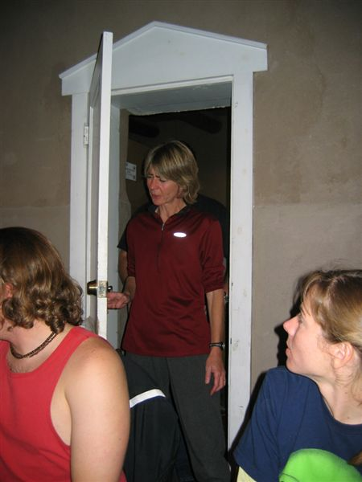

Miz Schaeffer coming out of the closet!!!

Finally, the pack got down to business – naming Just Colin. After asking him a little about himself, i.e., his likes, dislikes, past criminal history, etc.; he was excused from the room (a forgotten tradition now duly executed). There were a few suggestions about his appearance and some about his eating habits (Eats His Meat) before Rapid Shitty suggested Premature Extrapolation (you know… Just Colin being a math major and all). With enough beer, the pack found it acceptably funny (although, not very embarrassing in hindsight!) to call him back in and anoint him. At this point Nothing led the pack in prayer and the hash was declared “done” (well… maybe a little undercooked, but done enough for everyone’s tastes).

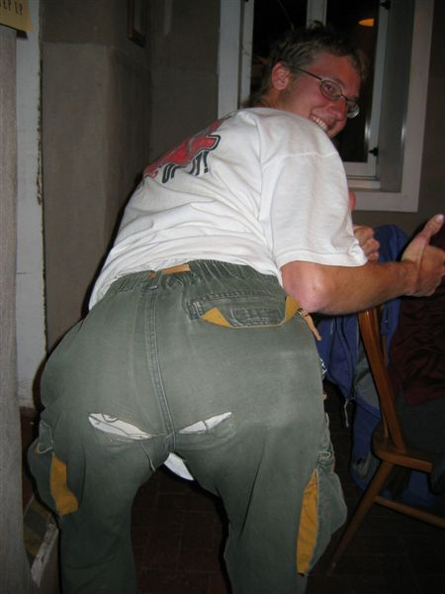

Premature Ejaculation – the butt of all jokes!

ON ON!!!

Next Hash Date: 9 December 2004 (the SECOND THURSDAY!!)
Next Hash Hare(s): Nothing’s Hung Like A Deere

REMINDER: IT’S OUR ANNUAL RED DRESS HASH!! WOO-HOO!!

