SH₃ Hash Trash

Vol. 2, No. 8 Hash No. 18
Hash Date: 5 August 2004
Scribe: Nuclear Semen
Hares: Father Snowball, Nothing’s Hung Like A Deere, & Virtual Clinton

Hashing is now “legal” in Socorro!!!! Celebrating our 18th hash we can now vote, etc. But we still have a couple more to go before we can drink (yeah, like that would stop us!). 14 (wow, they’re multiplying like hares!) hardy souls came out (or just “came”) for a lightning-shortened hash. Gathering at the brewpub (looks like this is our standard watering hole – they haven’t kicked us out, yet) were yours truly, Nuclear Semen; Father Snowball; Virtual Clinton (can I get an autographed copy of your new book? … wait, that’s not you); Nothing’s Hung Like A Deere; Wet & Hairy Banana Fairy (what hair?); Padre VLAAAAA; Miz Schaffer, Can I Go To The Bathroom (“You mean, may I…”); 7 Inches Shy (who wimped out to pack for a trip the next day…I don’t know about that…); Just Colin; Just Rheda; Just Evelyn; Just Diana (if you want her e-mail address, it’ll cost you); Just Amy; Virgin Jen; and Virgin Addy (whew! …I thought I would forget someone). Introductions were made. The hares began to plot their course (seems that 2 of them didn’t even know they were doing it …or should I say they didn’t know WHAT they were doing!). The hares departed (that’s Hare Father, Hair Nothing, and Herr Virtual) while Mother Time (Just Diana) kept them honest. Pitchers were emptied and the pack prepared for the chase. Nuclear Semen provided the chalk talk for the virgins (although the Boob Check symbol was new to some of the “Justs”…someone asked for the “Ball Check” symbol …OK, ladies, I’ll provide that next time and you can make sure that all the males “measure up”); and the “game was on.”
Beginning with a check (it seems like we always start with a check) the pack quickly picked up true trail behind Nuclear Semen. Proceeding out to California Street, the pack encountered the next check. After a couple more checks, including one that teased the pack with a “tour” of the new Wal-Mart (buildings under construction were made for hashing), the first BN was reached at the Roadrunner Lounge. The hares had brew and goodies ready and waiting.

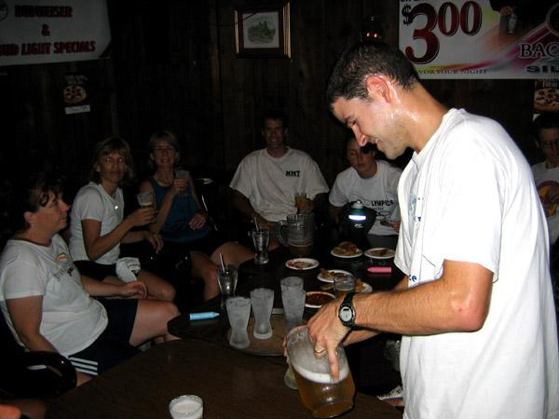

Wet & Hairy Beer Fairy!

Following his address of the Lions Club (something respectable??), Virtual Clinton rejoined the pack. The, now two, hares departed while the pack indulged in brew and munchies. After the obligatory 10 minute delay (at least as far as Nuclear Semen could determine), the pack began its pursuit under ever-threatening skies. The trail worked its way south with several checks thrown in for good measure until a turkey-eagle (T-E) split was encountered at the Motel 6 (… and they left the lightning on!!). It was a rather wimpy (REALLY, NOW!) T-E split, though, as the eagles merely went behind the motel. The hounds were hot on the trail, heading west just past Motel 6. Confusion reigned at the next check as the FRB’s couldn’t initially find trail (good job, hares!!).

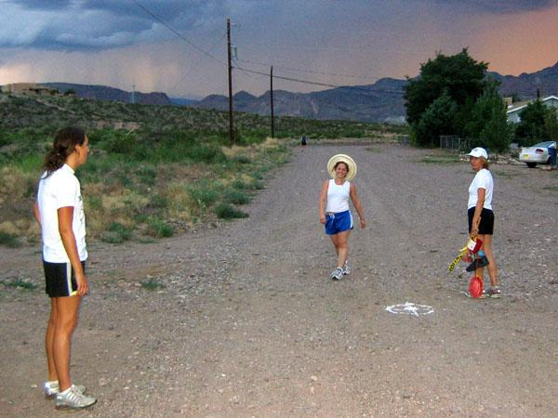

Are we lost, yet?

But Nuclear Semen, being a wily hound (and hare of sorts), quickly sniffed out true trail as it proceeded off-road through some true shiggy! The trail led up a steep hill to the backyard of Len Trusdale’s abode (for those who know him). The pack got stretched mighty thin going up The “HILL”!!!
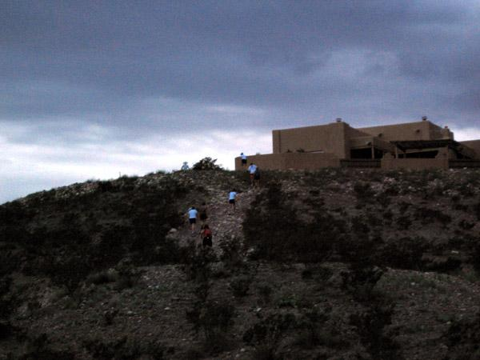

The “HILL”!!!!!!!!!!!
After a couple more turns, the trail led to the next BN (great BN placement, hares …the FRB’s had a hard time finding it) on the patio of the Alvarezes. Here, Here to Marcos for being such a gracious host!!!
With a rather violent thunderstorm threatening, the hares consulted with Nuclear Semen (as the resident storm expert …at least I like to think so!) as to whether or not it was safe to proceed as originally planned. Usually, a little rain is of no consequence. Even a lot of rain (and hail) is of little consequence; but a roasted hare or hound – not a “good thing.” The “light show” was probably the most spectacular one of the summer. Consulting the chronometer and erring on the side of safety (hard to believe that any hasher would ever consider “safety” important!), an ON IN was declared, a song was sung in honor of our host, and the pack and hares headed back to the brewpub.
The congregation gathered on the patio and Virtual Clinton led SH₃ with a good helping of “religion.” Father Snowball made a late entry and impressed no one with a Boob Check.

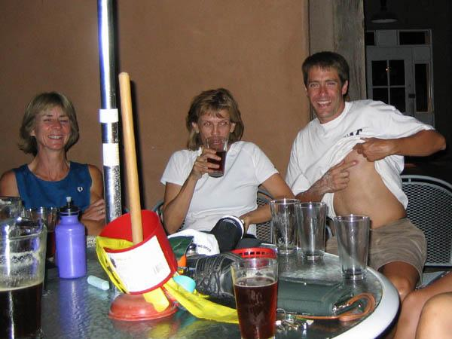

Father Snowball shows all how to perform a “Boob Check.”

The hares were roasted for their “shitty trail” (although Father Snowball had some problems consummating his down-down). Miz Schaeffer, Can I Go To The Bathroom, with her two virgins in tow, was feted for making Virgins (now Justs) Addy and Jen “come.” Well done to Just Addy and Just Jen for fully consummating their down-downs.

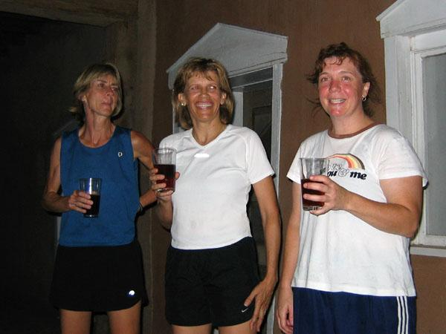

Miz Schaeffer and Virgins/Justs Addy & Jen do a Down-Down.

Crimes on trail were exposed. Several were charged and convicted for use of “wanker” names. And, as usual, Father Snowball was given a down-down for breaking tradition for NOT wearing any “R” gear. Just Colin received the FRB of the Hash down-down.
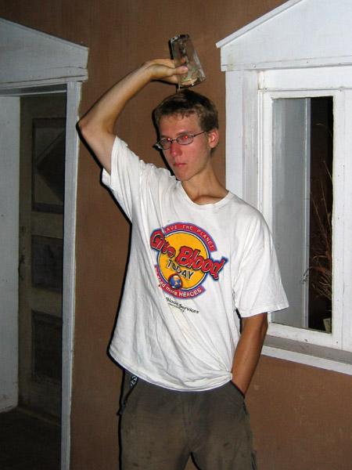

Just Colin – FRB of the Hash! (Yeah, it’s empty!)
Religion concluded with all rising for the Our Lager benediction (to which no one could remember the exact words …we should all get a down-down for that!). The ON IN turned out to be a wise decision as the heavens parted, forcing all to huddle a little closer under the umbrellas while eating (cozy wasn’t it?).

ON ON!!!

Next Hash Date: 2 September 2004
Next Hash Hares: Virtual Clinton (Possibly a Pick-up Hash)

