SH₃ Hash Trash

Vol. 3, No. 10 Hash No. 33
Hash Date: 6 October 2005
Scribe: Nuclear Semen
Hare(s): Virtual Clinton

Well, for those of you who “slacked off” (and that’s the majority of ya’ll!!!), you missed the greatest hash ever held in Socorro!!! The five TRUE HASHERS who showed at the Socorro Springs Brewery were rewarded with great shiggy, incredible beer, and a grand tour of Socorro and it’s environs. Present were yours truly, Nuclear Semen; Virtual Clinton, our hare (due to the small number of hashers); Gritty Gash; Just Kathy; and Just Cathy (didn’t I just say that?). Originally, this hash was touted as being a “pick-up” hash with everyone participating; but that would have been difficult with only four hounds. So, everyone agreed to let Virtual hare solo since he had already planned out the basic course.
After waiting for other potential hashers to arrive, Virtual headed off to lay trail. Meanwhile the pack finished off the remaining brew. After ten minutes, the pack headed out to find their first check at the bottom of the stairs. True trail was found to head west to California Street where it turned north. Near the north end of town, (do I have to give you a clue?) the trail crossed California and headed behind the Eagles Club. It then wound through the parking lot of K-Bob’s Restaurant and west through some of the best shiggy imaginable. Within seconds, everyone was four inches taller; then, four inches shorter; and then, four inches taller! Upon reaching Camino Real (and after everyone semi-cleaned their shoes), true trail headed south where the next check was encountered. The ladies found that true trail continued south on Camino Real and west into the new subdivision behind the Mormon Church. It was there that the pack came across the only turkey-eagle split of the hash. With such a small group, everyone decided to be eagles (for a change!).
The eagle trail (since I know nothing about where the turkey trail went!!!) headed west and across the back wall of the subdivision. Climbing the wall, the pack followed the trail along the muddy ditch bank (wow!… more shiggy!!!) until it reached the western outlet of the Gabaldon subdivision, where it headed west to Lopezville Road. Then, to everyone’s surprise, the trail crossed Lopezville Road and headed west through the desert. Finally, the trail came to the large diversion channel and headed south along the bank. As daylight waned, the trail took another turn to the west just north of EMRTC, through massive shiggy, over to the north access road. If that wasn’t enough, the trail continued west along the dirt road to the controlled area of EMRTC (and still no BN!). In the darkness, the pack climbed the fence (now we’re in trouble!) and started following the road that goes around the north side of M Mountain. Finally, the trail headed off the road to the south – eventually arriving at the Aerojet facility (whew!… by now everyone was tired!). Following true trail through the control point gate (actually, climbing the gate as it was closed and no one was there at the guard shack), the pack headed down past EMRTC, through the golf course and New Mexico Tech campus to a check at the entrance to the parking lot of the pool. True trail was found, heading east to School of Mines, arriving at the only BN of the hash at Virtual’s house.
After all that, the “spread” awaiting the tired and hungry pack was more than welcome. Beer, wine, cheese… everything a hasher could want! Everyone agreed that On In should be declared after feasting at Virtual’s house for, what seemed like, an hour. The group headed back to the brewpub and ordered food (we needed more!).

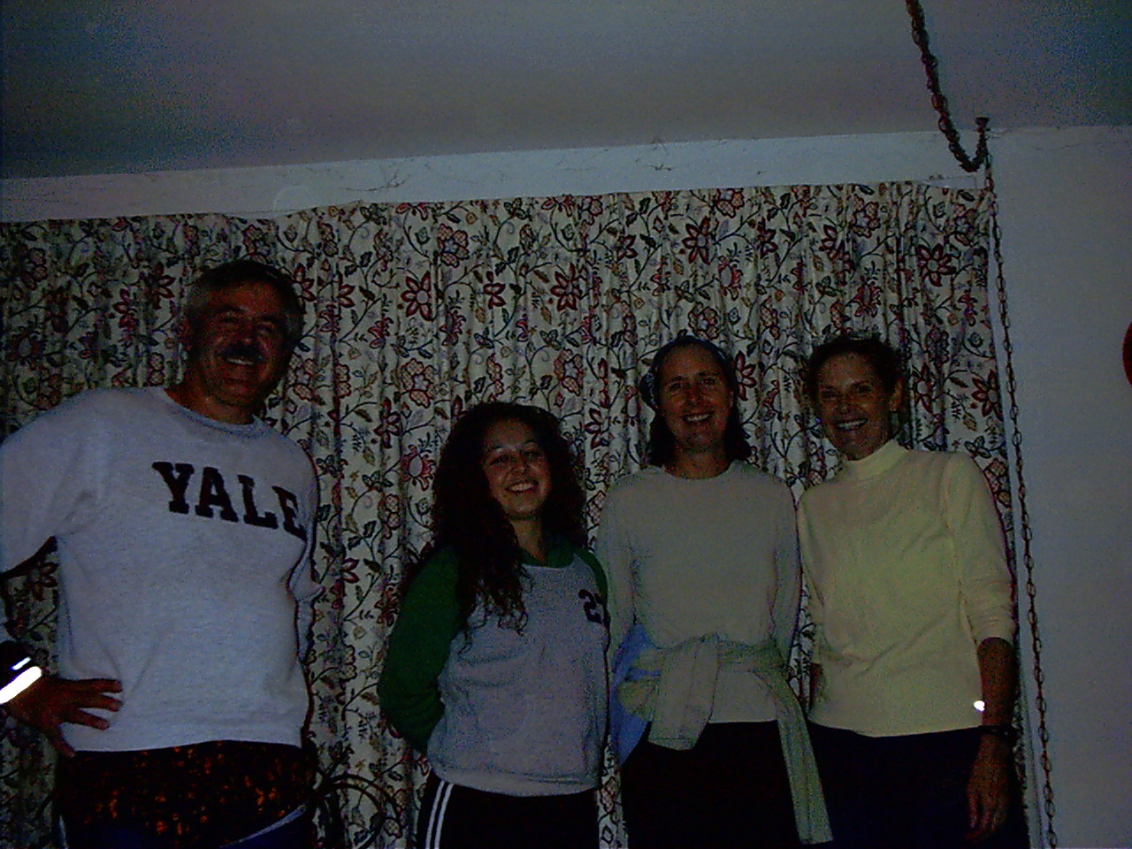
Trail-weary hashers at Virtual Clinton’s house.

While waiting, Nuclear called Religion to order. Virtual was toasted for his incredible trail, though everyone agreed that there wasn’t enough shiggy or beer. Crimes on trail included the usual wanker names, finger-pointing, etc. Eventually, everyone received a down-down. With no virgins, 5-timers, or blood-on-trail; Nuclear concluded Religion with the Hasher’s Prayer.
Plans were made for the Halloween Hash (one of our favorites!!!). Padre VLAAAA (who’s he?… there’s no one here by that name!) has offered to hare (with likely co-hare Virtual). The date for the hash was set as 27 October. BE THERE… OR BEWARE!!!!… THE TRICKS MAY BE ON YOU!

AND… If you don’t believe a word of this, you’d better show up to hear “the rest of the story!!!”

ON ON!!!

Next Hash Date: 27 October 2005 (Halloween Hash!)
Next Hash Hare(s): Padre VLAAA & ????

