SH₃ Hash Trash

Vol. 3, No. 11 Hash No. 34
Hash Date: 27 October 2005
Scribe: Nuclear Semen
Hare(s): Padre VLAAAAAA

It was a dark and stormy night… wait… that was another night! What a difference three weeks makes! Maybe it was the fact that everyone could dress up for this hash (so none of their “straight” friends would recognize them!) or maybe it was the hare (nnaahhh!). Anyway, nine souls (some that should have been departed) showed up at the Socorro Springs Brewery for the annual Halloween Hash. Present were yours truly, Nuclear Semen (as a New Zealand All Black rugby player… only in my dreams!); Virtual Clinton (the Dreaded Roberts, scourge of the high seas); Nothing’s Hung Like A Deere (the Arkansas redneck with a full mullet… looked like a dead squirrel got stuck on his head!); Second Hand Dyke (our Barbie doll… trying for another proposition like last year???); C Major Ass (the Zombie Priestess… definitely not going to get propositioned this year!); Mutton Honey (a 50’s teen… I think you’re a bit too young to actually have been one… unless you’ve lied to me about your age!); and Padre VLAAAAA (a really “BAD” hare [day]…). Rounding out the pack were Just Kathy (wearing whatever she found in her kids’ closets… honestly, no kidding!) and Just Clayton (a Hawaiian superhero).
After waiting for more to show (those others known as SLACKERS!!!), the hare was sent off with a ten-minute lead. He noted that there would be a new mark on the trail. He said that it would be obvious and the pack should go up to the door of the nearest house and ring the doorbell when this new mark was encountered. The pack quaffed their ales (or water) and headed out at the appointed time.
From the initial check, true trail was found, leading east out the back parking lot of the brewpub and south down the back street. At the corner behind the Chinese restaurant, the trail headed west and across (where would a Socorro hash be without at least one crossing!) California Street. The trail then led behind the Tastee Freez and over to the street paralleling College before continuing west. Near the end of the street, the first of the “new” marks was encountered (similar to that below). It was obvious from the Halloween “paraphernalia” out front (and the beer offered!) that this was the first BN for the hash. “Trick or treat” soon became the standard cry.

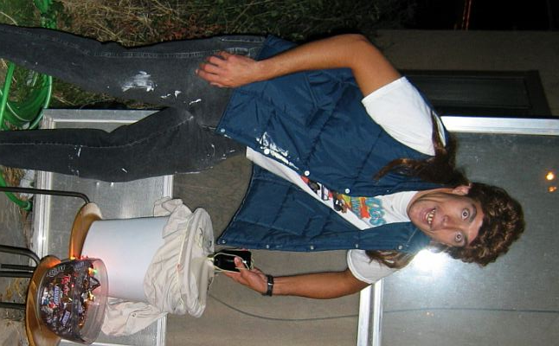
Our host, Collin, offered candy and brew - but with a catch! Those with an early thirst had to brave putting their hands into the “mystery” bucket. Those who did were rewarded with an ice cold one (though a bit slimy!).
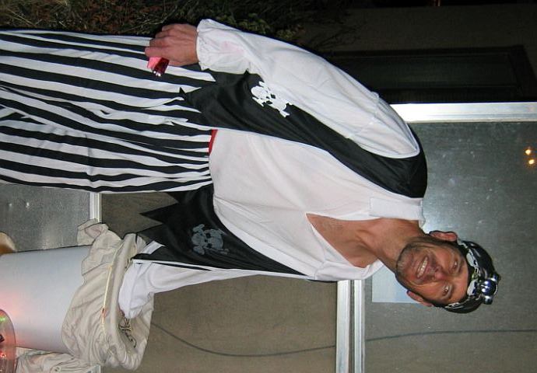
The Dreaded Roberts & The Redneck brave the “Mystery” bucket.

The host, clearly enjoying the festivities, was toasted (and sung to!!) for providing such a great TREAT! He further indulged the pack by taking a group photo.
Taking their leave, the pack headed off in search of true trail, which was found to head west to the ditch bank, then north to the intersection of Campus and Franklin (Camino Real). From there, the trail headed south on Franklin, past School of Mines - on to Neel. At Neel, the trail headed west towards New Mexico Tech past Papa Don’t Preach’s house. Soon, a second BN was encountered (at least that’s what the pack thought!!). After ringing the doorbell, the pack, in three-part harmony (what did you expect me to say… that it sounded like a cat fight?), greeted the owner with a rousing “Trick or Treat!” The owner gave the pack a perplexed look and said he didn’t know who we were or why we had stopped there! Well, now it was unclear what should be expected at the “marks” thought to represent BN’s. With that disappointment, the pack headed on, following true trail over to School of Mines and north along Sunset to Campus. At Campus, true trail headed west and onto the campus of New Mexico Tech. Cutting across the parking lots on the northeast corner of the campus and heading north, true trail arrived at Bullock. From there it headed west to Lopezville Road, where it turned and again headed north into the darkness (I never realized there are no streetlights out that way!).
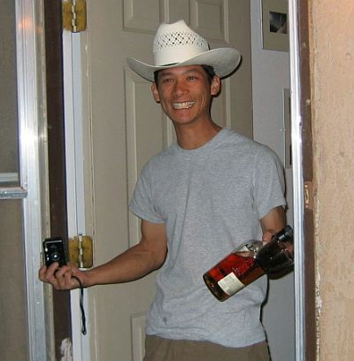

Host of the first BN – Collin (I like what he has in his left hand!).

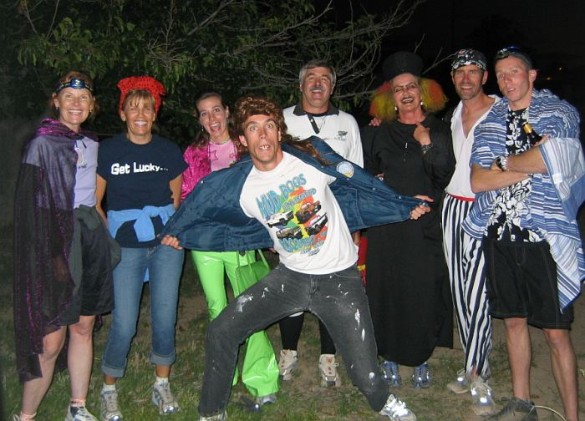
A ghoulish pack, if ever there was one (lock your doors, folks!), at first BN.
Past the NRAO Operations Center, the trail turned west into the subdivision north of the golf course. True trail continued west and then turned north at the last cross street. At the end of that street, the trail headed west to the next special “mark” (with everyone wondering whether or not it would be a BN!). It turned out to really be a BN; and the pack was welcomed with more beer and candy.
The stopover was brief with the host ushering everyone into the back yard. There, the pack found a true trail “maze” heading around the pond to the west side of the house, through the nearby shed, and across the “plank” (much to the delight of the host… probably wondered what idiot would follow a trail of flower in the dark).
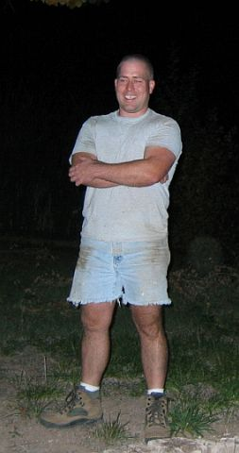

The bemused host of the second BN.
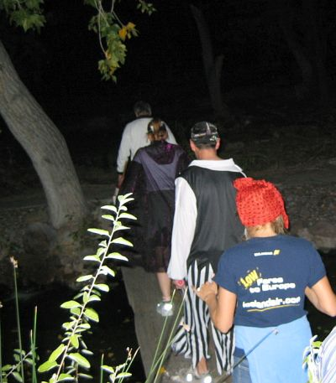

The PLANK!

Eventually, the pack ended up back at the front of the house where true trail was discovered, leading up the dirt hill to the north. In the dark, the rocks and bushes made for an interesting trek over to the next street where true trail headed east down to Lopezville Road. There the trail briefly headed south until turning east. Within a few blocks, the trail turned back south, making its way to Bullock. At Bullock, true trail turned east and headed to the Mountain Spring Apartments (Tech’s “new” dorm!). There, another new “mark” was found outside the door of, none other than, our own Just Jayme (who had recently been seriously ill and was still recovering). Everyone felt it a treat just to see Just Jayme back in Socorro. Just Jayme had more beer and candy for the pack (the third BN of the night) – but she expected more in return than at the previous BN’s. She asked Rugger Nuclear to perform a haka (a traditional Maori war chant performed by the New Zealand All Blacks rugby team before their international matches… smart girl!!). The pack also regaled her with song. At Just Jayme’s, a mysterious stranger (never did catch his/her name!) attempted to whisk away our beloved Barbie. Just Jayme also treated the pack to her “licking rock.” Nearly everyone took a turn getting the rock stuck to his or her tongue (this would prove to be a great conversation piece back at the brewpub!). Bidding farewell to Just Jayme, the crew again headed off in search of the true trail.

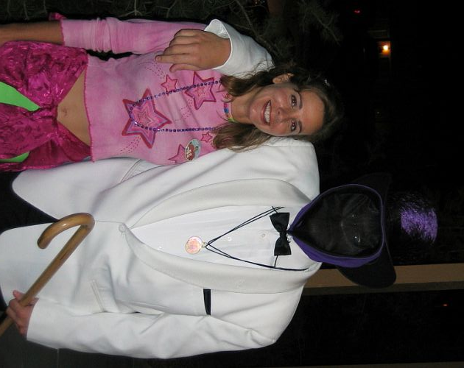

The Mysterious Stranger with Second Hand Barbie!!!

True trail took the pack east along Bullock and across (you guessed it!) California Street. The trail then cut through behind the old Yellow Front Store (now the Indian craft store) to the street east of California. There it turned north until a true trail mark was encountered, leading the pack east on a dirt driveway to Padre VLAAA’s old abode for the final BN (it must be a record… four BN’s??). Not everyone made it to the final BN!!! Notably absent were Redneck Nothing, Second Hand Barbie, and C Major Zombie!!! Only after much effort, did Rugger Nuclear get Redneck Nothing’s attention and guide him to the BN. Seems the three lost souls had stopped for a photo opportunity and gotten separated from the rest of the pack (likely story!!). Assuming that the pack had headed to the brewpub (and where did the trail lead… ???), they had declared their own On-In!
On-In was declared (officially!) and the pack headed across and up the street to the brewpub. Before getting started, someone spied Gritty Gash hiding inside the brewpub. That was enough for Redneck Nothing and Rugger Nuclear to go on the hunt for the wayward Gritty. She made a vain attempt to hide in the ladies room; but when did that ever stop a hasher! “Outed”… Gritty was forced to confess her crime of “slacking” to the group and beg for mercy!

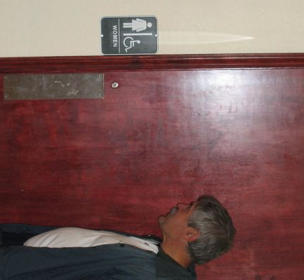

Oh, Gritty… We know you’re in there!

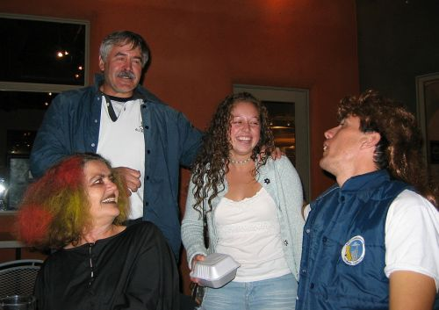

Rugger Nuclear forcing a confession out of Gritty!

With brew and food ordered, Rugger Nuclear called Religion to order. The hare, Bad Hare VLAAA, was roasted for his long first leg, lousy BN’s, and lack of shiggy. With the singing of Shitty Trail, Bad Hare VLAAA was assessed a down-down. Crimes on trail consisted of the usual litany of hash fouls and Rugger Nuclear eventually assessed a down-down on everyone (when one drinks, they all drink!). FRB honors (and an appropriate down-down) were awarded to the Dreaded Roberts. With that, Religion was closed with a weak recital of the Hasher’s Prayer, led by Redneck Nothing (when are we going to get it right??).
The next hash was discussed. Nothing and Second Hand volunteered to co-hare. The theme was decided to be NO THEME! Then it was time to have some fun with the waitresses.

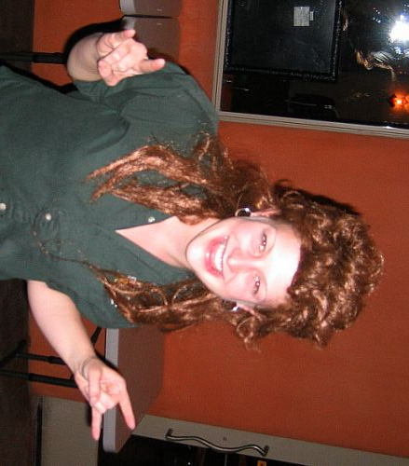

Waitress with dead squirrel on her head!

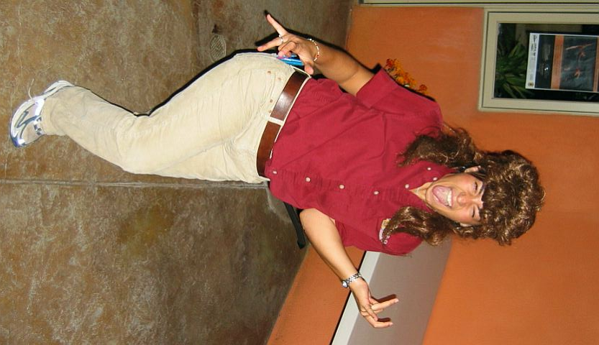

That “dead” squirrel must have been alive by the way Katrina’s screaming!!!



A close-up of the Zombie Priestess (Ouch!).

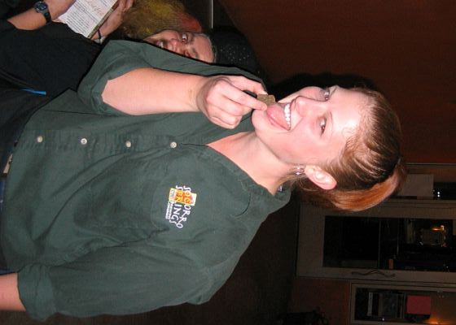

Trust me! Just lick the rock!

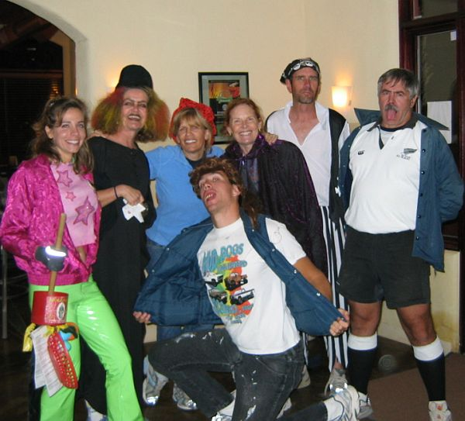
Final group shot of the evening (after this, they kicked us out!!).

ON ON!!!

Next Hash Date: 17 November 2005 (No theme!)
Next Hash Hare(s): Nothing’s Hung Like A Deere & Second Hand Dyke

