SH₃ Hash Trash

Vol. 3, No. 13 Hash No. 36
Hash Date: 8 December 2005
Scribe: Nuclear Semen
Hare(s): Virtual Clinton

It was a cold, dark night (really… it was!!!). A bone-chilling 32º F greeted the M Mounters as they gathered at the Socorro Springs Brewery for the annual Red Dress Hash. It was the coldest night for a hash that anyone could remember! Most everyone (there were a few foolhardy exceptions) dreaded heading off into the icy darkness (in dresses no less!); but… “the show must go on!”
In attendance at this formal affair were yours truly, Nuclear Semen (in a red pony skirt… sort of); Virtual Clinton (hare du jour in a sleeveless thrift-shop special); Mutton Honey (also in a sleeveless dress); Nothing’s Hung Like A Deere (also sleeveless); and Second Hand Dyke (you guessed it!). Rounding out the pack were Just Jayme (in a lovely SLEEVED dress); Just Pat (in polka dots… didn’t do a thing for him); Just Kathy (she did have a red dress on somewhere under it all… I think!); and Just Fish (in a halter top with no shirt!!!… I did say there were some exceptions to those who dreaded heading out into the cold!). With Just Jayme, Just Pat, and Just Kathy each running their fifth hash, it looked like it could be a LONG night!
With drinks in hand, the gang waited in case any others would show. But, alas, the appointed hour came and Hare Virtual was sent off with a fifteen-minute head start. Waiting behind, the pack finished their drinks and pondered whether or not it was worth chasing after Virtual (warm inside – gooood!… cold outside – BAAAD!!). Eventually, the pack headed outside in search of true trail. From the initial check, true trail was found heading south behind the brewpub, circling around, over a fence, and through to California Street in front of the Yellow Front store. The trail crossed (WOW!… who would have guessed!) California to the Kentucky Fried Chicken and headed into the Smith’s parking lot where a photo check was encountered. Following the great photo op(portunity), the pack continued in hot pursuit of Virtual, heading west on Campus. The trail cut north on one of the side streets to Bullock before heading west again. Here, the hash nearly met with disaster. A “ghost of hashes past” (a left over true trail mark from a past hash) scattered the pack for what seemed like an eternity. Just Jayme, being the only one to recognize what had happened, lacked the vocals to get everyone else’s attention. Finally, the pack regrouped and got back on “tonight’s” trail. The trail was followed, heading west on Bullock to the ditch, where it turned south. Upon reaching Campus, true trail headed west again, and then turned south on Bursum past Nuclear’s house. At School of Mines, the trail headed past Virtual’s house (no BN??!?) over to Leroy where a check was encountered.

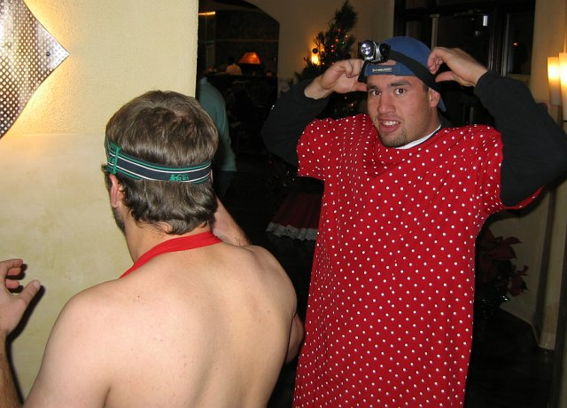
Justs Pat and Fish prepare to head out in search of trail. BRRRR, Just Fish!!!
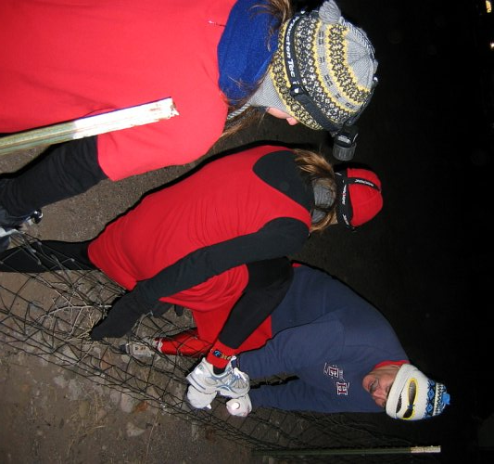

Nuclear helping Second Hand and Just Jayme over the fence.

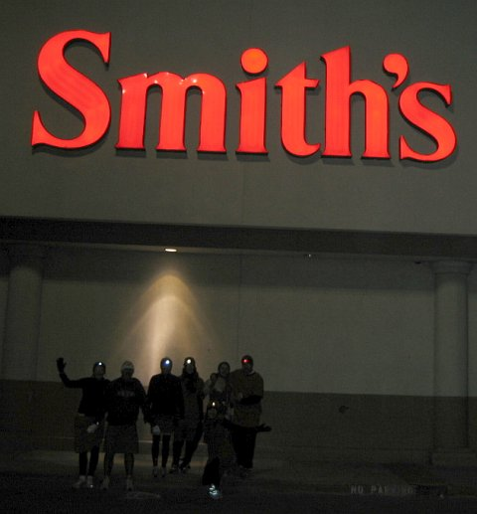

Well… at least you can tell WHERE we were!

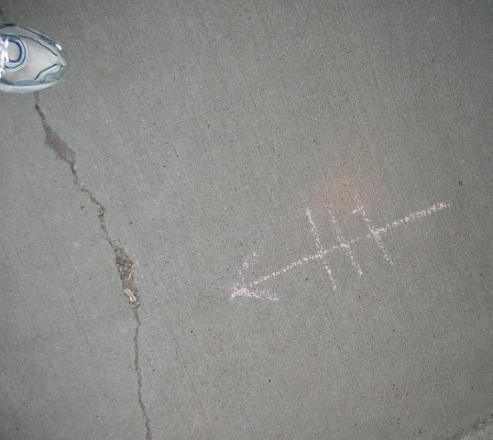

The “Ghost of Hashes Past!!!”
True trail headed west onto the New Mexico Tech campus and, first, through the gym and, then, through Speare Hall. Out the back of Speare, the trail headed north to Bullock, where it turned east. A couple houses down the pack arrived at the first BN at Bill and Sara Marcy’s house. Our gracious hosts had a great spread laid out for the M Mounters. If not intentional, it sure seemed to fit in with the current clientele, a book on flatulence (okay… FARTS!) was found on the living room coffee table. In gratitude to our hosts, NO gross songs were sung and we helped add a few ornaments to their Christmas tree.

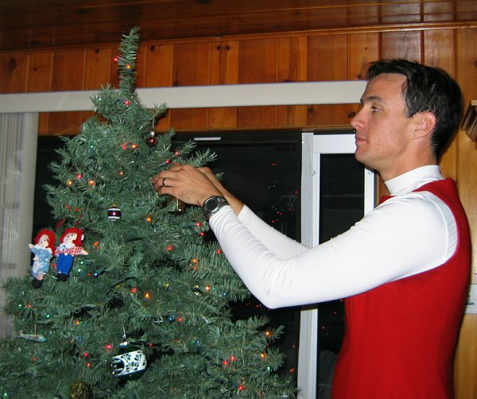

Nothing helps decorate the Marcy’s Christmas tree.

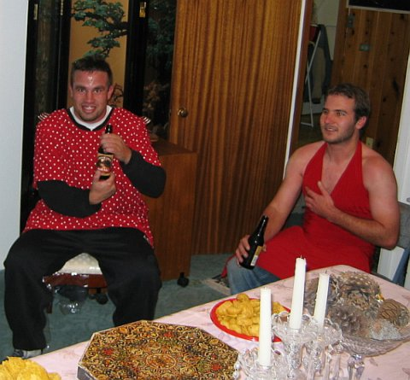

Justs Pat and Fish enjoying some refreshments. Note the crystal – CLASSY!

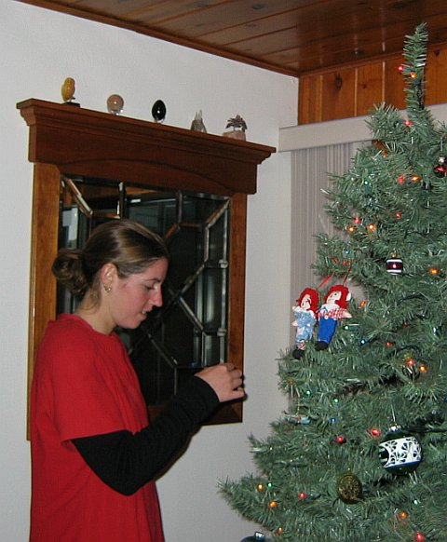

No, Just Jayme… put it over more to the left!
Well… all good things must come to an end – ESPECIALLY BEING WARM!! Virtual headed out into the icy air with a ten-minute lead. The pack followed at the appointed time (more or less…), finding true trail leading eastward on Bullock. At the corner with Leroy, the trail turned south to Campus, where it again headed east. At Franklin, true trail went onto the ditch bank, heading south. Before getting to the San Miguel Church, the trail took another turn to the east winding around Ace Hardware and arriving at the final BN of the evening – the El Matador lounge.
It was agreed that the El Matador was as good a place as any to hold Religion; so, Nuclear called Religion to order. Hare Virtual was roasted for having too little “old” trail, disrupting too few classes (yeah… what was that guy yelling at us about in Speare Hall???), too many T/E splits, and too few checks. Virtual was assessed an appropriate down-down for his lack of attention to trail detail. Then, Nuclear called for Crimes on Trail. Everyone was assessed a down-down for not hearing Just Jayme’s “audible” and wasting time in search of the trail when the “old” true trail mark was encountered. Nuclear was assessed a down-down for his lack of a “proper” red dress. Second Hand suggested taking up a collection to buy Nuclear a dress for next year’s hash. Nothing achieved FRB honors (nothing unusual about that) and Justs Jayme, Kathy, Pat, and Fish took DFL honors (Just Jayme has an excuse… what’s the story on the rest of you?).
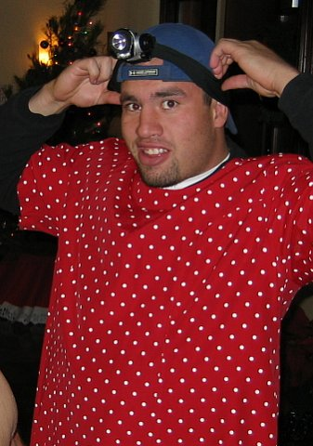
With the “trivialities” out of the way, it was agreed to name Just Pat first. Belying his rugged rugby persona, the monikers Giggles, Babycakes, and Cupcake were suggested. After some discussion, the pack decided upon GIGGLES as it seems he can never stop laughing. The tribe had spoken!

I present to you Giggles (the Clown)!!!
As it was thought that Twiggy Flanders was planning to join the crew for naming Just Kathy, Religion was recessed while everyone headed over to the brewpub. It was a hoax!!! Anyway, Religion was reconvened and the naming of Just Kathy commenced. Recognizing her Bay Area (California) roots, names such as Bay City Boozer, Flower Child, Alcatramp, RN (based on her current educational pursuits – whatever it was intended to stand for!), and Sponge Worthy Flour Plow (who came up with that one???) were put on the table. Finally, after some debate, the pack voted for ALCATRAMP. The tribe had spoken!

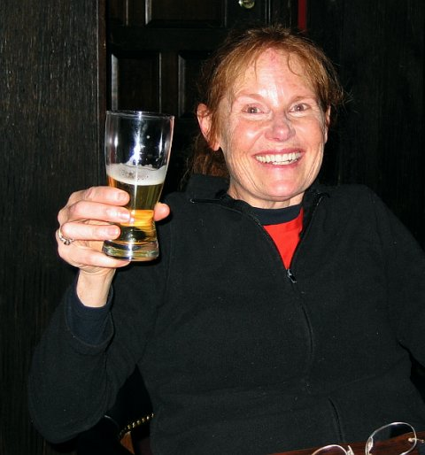

I give you (drum roll, please!) Alcatramp!!!

Last, but certainly not least, came Just Jayme. The questioning seemed to last forever with Just Jayme (maybe because the answers were so JUICY!!!). Apparently, this little Philly (from Philadelphia) is an avid Eagles fan (and Dallas Cowboys hater!). It’s not hard to imagine where things were headed after this revelation. Thus, names such as Dallas Cowgirl, Eagle Plucker, Giant Cowgirl, and Used Cowgirl came up for consideration. In the end, the pack decided on USED COWGIRL. The tribe had really spoken!!
With that, Religion was concluded with the Hasher’s Prayer (Bar Men!). A date for the next hash was selected (so that the students would be back) and Nuclear and Alcatramp agreed to co-hare. It was agreed that the M Mounters should meet at the El Matador for the next hash.

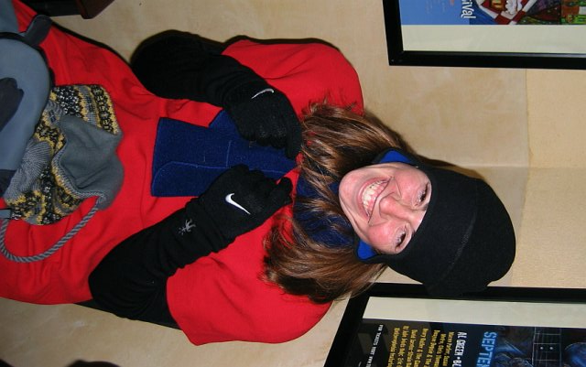

Our little Philly, Used Cowgirl (bundled up for the cold)!!

ON ON!!!

Next Hash Date: 19 January 2006 (Over-The-Hill Hash)
Next Hash Hare(s): Nuclear Semen & Alcatramp

