SH₃ Hash Trash

Vol. 3, No. 1 Hash No. 24
Hash Date: 20 January 2005
Scribe: Nuclear Semen
Hare(s): Virtual Clinton & Miz Schaffer, Can I Go To The Bathroom

WOW!!! We’re already into our third volume of trash … and it just keeps getting better all the time! It was a great turnout for a run in the dark with yours truly (Nuclear Semen); Virtual Clinton (hare superior); Miz Schaffer, Can I Go To The Bathroom (that’s “may I go to the bathroom”) (hare novitiate); Nothing’s Hung Like A Deere; Second Hand Dyke; C Major Ass; Rapid Shitty Anal Cyst (RSAC); 7 Inches Shy (MAJOR slacker!!!!); Just Addy; and Just Nico (hail, Joseph!) making it to the Socorro Springs Brewery (which is moving sometime after our next hash – they hope … hope they’ll tell us where they’re moving to).
Hare Schaffer was notably nervous about her first hash, laying trail (better than laying an egg!). It was only fitting that her co-hare Virtual and the pack should try to push her over the edge by intimating that Virtual was too “ILL” to assist. Unfortunately, Virtual didn’t give a very convincing performance (BOO! HISS! Throw him off the stage!). With that vote of (NO) confidence, the hares were sent off to carry out their duties.
With Miz Schaffer out of the way, the pack plotted her demise (tell US that you “really, REALLY like” your hash name!). Nothing indicated that he had a great new name for Miz Schaffer (and shorter, too!); so, it was agreed that she would have a new moniker by the end of the evening!
After giving the hares a 15-minute head start, the pack proceeded into the night and began walking out the possible trails from the first check. True trail was picked up by Just Nico, heading south towards and across the plaza. The FRBs headed out the southwest corner of the plaza, but Nuclear and Just Addy noticed trail marks heading east and eventually towards the county courthouse. From the courthouse, true trail headed west and then turned south again. At Highway 60, the trail headed east for an obligatory crossing of California Street. The pack took one lap around Clarke Field and then struck out to the north. After a short run around on the east side, the trail headed west across (but of course!!!) California Street and then back north. By this point, the pack was getting pretty well spread out. In fact, it wasn’t very “packed” at all and the DFLr’s were starting to get lost!

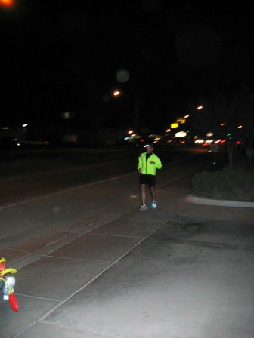
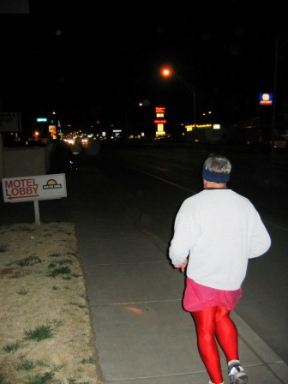

7 Inches Shy followed (?) by Nuclear Semen

At the Ace Hardware, true trail turned west out into the “dark world” and worked over to the ditch bank, where it headed north along the ditch. At Campus Street, a back check was encountered. As luck would have it (and it was PURE, DUMB luck!), the trail was found breaking off of the ditch bank, heading east. Following the hash marks behind Smith’s, the trail continued north, past Sedillo Park to Parkview Elementary School. At first, Nuclear thought Miz Schaffer might have planned for a BN at her classroom (well … it was just a thought!) until a YBF was encountered. Backtracking, the majority of the pack headed east on true trail towards (you guessed it!) California Street. Nothing headed back to find C Major Ass who had been lagging behind. Crossing California, the trail led to a “pseudo” BN (faked us out!) and, FINALLY, to the real BN at the Holiday Inn (Hey, Just Addy, did you know where we were going?). After over an hour in the dark, it was good to take the load off and rehydrate (beer does rehydrate, doesn’t it?). Nuclear went back to guide Nothing and C Major only to find Nothing. C Major was nowhere to be found (fortunately, no bodies have been discovered since her disappearance!).
With some munchies and brew, the hares headed off for the next leg. The pack, meanwhile, started counting down the ten-minute delay and continued to indulge. Soon enough, ten minutes had passed and the pack headed off in search of trail. The trail headed (of course!) across California Street and turned north. Soon the trail headed west to El Camino Real where it took a turn south. As if the pack hadn’t wandered around long enough in the dark, the trail took off to the west and across the ditch. True trail then headed back south towards Tech. Reaching the campus, the pack was treated to a “tour” of several buildings. Into Weir Hall, up the stairs, down the hall, down a back stairway, and out the other side; then on to the gym, in the back door, down the main hall, and out the front door; and then across the street to South Hall, up to the second floor, down the side of the building, down the stairs, and out to the street (Whew!!!). Back on the street, true trail headed up Tech hill, around the corner to the south, and into a rugged alley (it was rough even with a flashlight!). Within a few minutes, the pack arrived at Miz Schaffer’s back yard, where the final BN was found. Indulging in some more munchies and brews, Miz Schaffer led the group in her first graders’ favorite song (when do we graduate? … though her students probably do it better!). ON IN was declared and the pack loaded up the truck and moved to Beverly … whoops! … wrong song (though we sure look like a bunch of hillbillies).

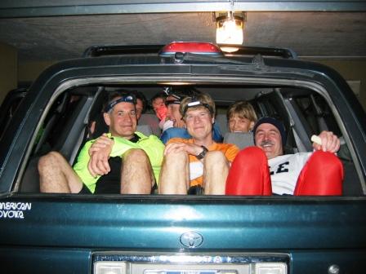

Sardines (front: 7 Inches, RSAC, Nuclear; back: Virtual, Second Hand, Nothing, and Just Addy; missing: Just Nico)!!

Soon, back at the brewpub, brew and food were ordered; and Religion was begun. First on the agenda, a toasting (although a roasting might be in order …) of the hares – Virtual Clinton and Miz Schaffer, Can I Go To The Bathroom. After a round of Shitty Trail, the hares drank their down-down. And it was onto the infamous “crimes on trail.” As nearly everyone was accused of using “wanker” names, EVERYONE eventually ended up with a down-down for failing to keep track of C Major Ass.

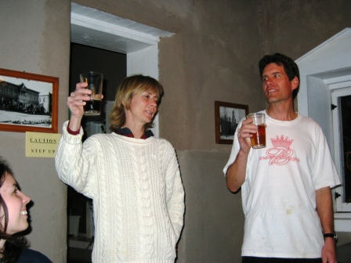

Hares Virtual & Miz Schaffer (no longer a “virgin” hare!)

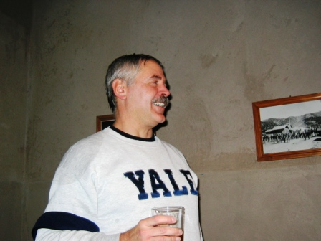

Nuclear getting to down-down!

In the midst of the festivities, Second Hand got a case of the hiccups. Everyone else was greatly amused by her attempts to quell the spasms (which didn’t help Second Hand any!). And as the saying goes, “If at first you don’t succeed, try, try again!”

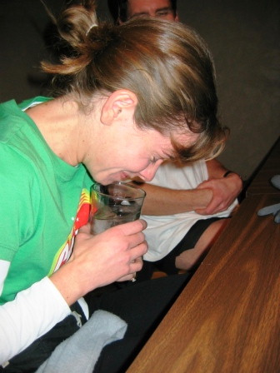

Second Hand trying Hiccup Cure No. 1 (Don’t Breathe!)

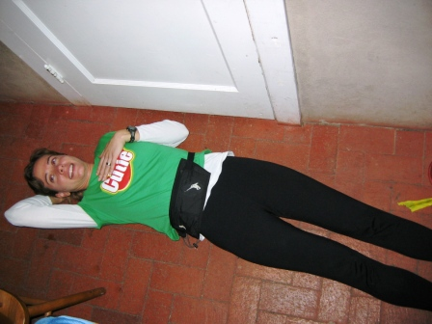

Second Hand trying Hiccup Cure No. 2 (laid out on the floor)

Finally, the highlight of the evening arrived – renaming Miz Schaffer!!! Sending Miz Schaffer’s daughter Brittany to the ladies room (young’uns is so impressionable!), the pack invited Miz Schaffer to justify WHY her hash name shouldn’t be changed. After some lame excuses, Nothing was called upon to propose her new name, Twat Blossom. Without any discussion, the pack unanimously declared that Miz Schaffer should, hereby and forever, be known as TWAT BLOSSOM!!!



I give you TWAT BLOSSOM (doesn’t have anything to do with a pig, does it?)!!

With that, the evening’s Religion was ended and the next hash was discussed. Virtual said that the hare would be a surprise. Everyone agreed that people should either wear pink or, as RSAC suggested, “have a heart-on” (Say that really fast and … get it?). Also, the idea for a “family friendly” hash was addressed. Thus, sometime in the near future, there will be a “family friendly” hash that kids can join in on … stay tuned to this station.

ON ON!!!

Next Hash Date: 10 February 2005 (the SECOND THURSDAY!!) (Valentine’s Day Hash – wear pink or have a “HEART-ON” … Please, guys, don’t get this instruction wrong!)
Next Hash Hare(s): A SURPRISE!!!

