SH₃ Hash Trash

Vol. 3, No. 3 Hash No. 26
Hash Date: 3 March 2005
Scribe: Nuclear Semen
Hare(s): Rapid Shitty Anal Cyst (RSAC) [Ghost Hare – Nothing’s Hung Like
A Deere]

Erin Go Bragh! The luck of the Irish to you all! For those who “slacked off,” may your skin turn GREEN.
In honor of the patron saint of Ireland, seven blessed souls gathered at the Socorro Springs Brewery for a night of hashing (who needs pot when you can hash!). Present for the festivities were yours truly, Nuclear Semen; Virtual Clinton; Second Hand Dyke; Rapid Shitty Anal Cyst (RSAC) (replacement hare dú jour); Nothing’s Hung Like A Deere (the “injured” hare); Wet And Hairy Banana Fairy (who?… where’d you come from?); and Just Addy (or, more properly, Just Arnfriður Kristjánsdóttir… but not for long!). Definitely, the hot topic was not green beer, but what to name Just Arnfriður …
With flour and chalk (and NO red chalk this time!) in hand, RSAC headed into the darkness. With time to “kill” the remaining brew, the pack kicked back and counted down the ten-minute lead given to RSAC. Heading out, the pack began scouting out the many trails. ON-ON was heard to the north, and the pack was off in hot pursuit of the hare. As luck would have it (Irish eyes were smiling!), true trail passed in front of San Miguel Church, where the pack paid its respects to St. Patrick (it wouldn’t be St. Patrick’s Day without him… now would it?). Continuing north, the pack came to the first check and, then, the first of several YBFs. Backtracking to the last check, true trail was found on the paralleling ditch bank. The trail then dropped off the ditch bank and headed east. The pack expected to cross California Street (no hash would be complete without it!), but was surprised when the trail headed north along California and quickly arrived at the first BN of the night – The Matador Lounge. RSAC was there and waiting. Beer was ordered and the few-remaining munchies were dug out of the buffet wagon. After such a short first leg, the first BN seemed to last forever.
But soon enough, RSAC was off with an eight-minute head start (the pack didn’t want to cut him any slack…) to set trail and, maybe, cast out some snakes. At the appointed time, the pack departed The Matador in search of trail. Following the trail into the back of the Econo Lodge, the pack fully expected another YBF… but the wily hare had set trail over the six-foot wall surrounding the back of the hotel. Only Second Hand “wimped” out and ran around the end of the wall vice climbing over it (wimp, wimp, wimp, wimp, wimp!!!). From there, the trail headed north through the various business parking lots before turning west onto a dead end street. Cutting through a fence the pack came to a “package” check at the intersection of Campus and El Camino. After a long search by the male species (they wouldn’t stop to ask for directions!), true trail was determined to be heading south along El Camino. Turning to the west at School of Mines, the pack encountered a “boob” check. Now, the female species took their turn at finding true trail, which was found heading south and then east down Fitch Street. The second BN was found there in the backyard of the Hales.

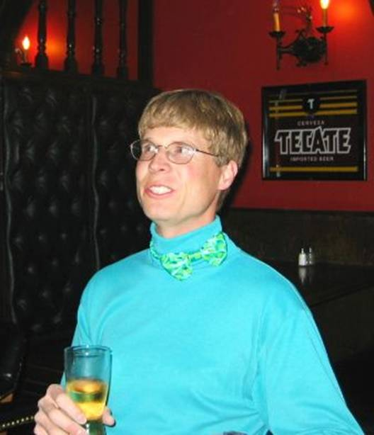

RSAC at 1st BN… at least the tie is GREEN (shirt… questionable)!

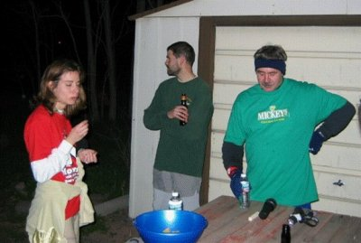

Second Hand (where’s your GREEN?), Wet And Hairy, and Nuclear at 2nd BN.

Arriving at the BN, Virtual realized that he no longer had the camera entrusted to his care by Nothing. After a search back along the trail he returned – camera in-hand (sounds like a crime on trail to me…). Indulging in some liquid refreshment and chips, the pack enjoyed the quiet of the evening. A heartfelt thanks to the Hales from the M Mounters for being so gracious as to allow such a motley crew to camp out in their backyard at the last minute.
Soon it was time to resume the hunt and RSAC took off, being allowed a longer head start than before. The pack soon followed after counting down RSAC’s allotted lead-time. Heading over to Neal Street, the trail then turned west towards New Mexico Tech. At the corner of the campus, a Turkey-Eagle split was encountered. Thinking it would be roughly an even distance (with a relatively fast, veteran pack), Nuclear, Second Hand, and Just Arnfriður took the Turkey trail while Virtual and Wet And Hairy followed the Eagle trail. Heading up around the Methodist church and then down by Second Hand and Nothing’s house, the Turkey trail passed through one check and eventually led to the final BN at RSAC’s house, where the threesome found “ghost hare” Nothing waiting. After a while, the four began to wonder what had happened to the hare and Eagles. Five minutes… ten minutes… fifteen minutes… Finally, after 20 minutes, RSAC arrived. The Eagles arrived about five minutes later. The Eagle trail had gone through New Mexico Tech (and through some of the dorms), up Tech Hill, around North Drive to the ditch, south along the ditch and into the cemetery and down Rocky Hill to the last check of the Turkey trail. RSAC reported that he had almost gotten lost, making the trail longer than intended. The Eagles hadn’t fared much better – almost getting lost as well. While the group was enjoying some more brew (the Guiness rounded out the Irish flavor of the evening) and munchies, Virtual decided to expose himself… and it was an ugly sight (see for yourself…) (don’t look if you don’t want to hurt your eyes)!!!

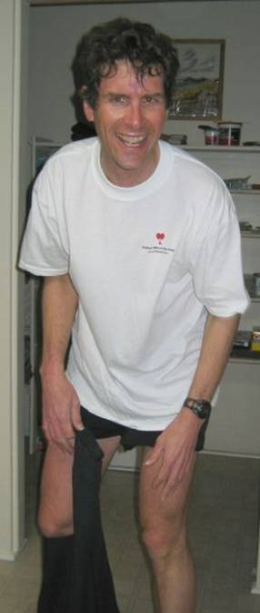

Virtual exposed (ouch, my eyes)!!!

At this point ON-IN was declared, beers were downed, and the group headed back to the brewpub. Back in the hallowed halls of Socorro hashdom (possibly for the final time), food and drink were ordered and the group began its evening ritual. Nuclear called the faithful to order and Religion commenced. The hares were roasted and toasted for their “fine” trail (although many complained that there were too many YBFs and that it was too long). RSAC and Nothing – never ones to waste an opportunity – gratefully accepted their down-downs. Then the discussion moved to crimes on trail. The usual bevy of “wanker” name-calling and inappropriate attire (NO GREEN!) were followed by Virtual accusing Nuclear of not having “sinned.” Thus, Nuclear (also, not one to waste an opportunity) joined in a mass atonement for transgressions committed and everybody had a down-down!
Ay, with the blessing of St. Patrick himself, the time arrived to anoint our sister, Just Arnfriður, with her hash name! Twat Blossom had been kind enough to send along a list of things to consider in the naming of Just Arnfriður, but the group began its own inquisition of the poor soul cursed with a “Just” title. Her husband, her homeland, her interests… all came under the scrutiny of the council. Names such as Mayor Layer, Sheep And Easy, Sheep Thrills, and Curry Come Guzzler were offered up. Dismissing Just Arnfriður, the council deliberated her fate and agreed upon MUTTON HONEY for her hash moniker. The pack had spoken!! With her introduction as Mutton Honey, Religion was ended with a very poor saying of the Our Lager prayer (very poor, indeed!!!!).
The next hash was discussed with the theme being Spring Forward! The meeting place will be the Socorro Springs Brewery if it’s still open. The backup location (just in case) will be the Valverde!

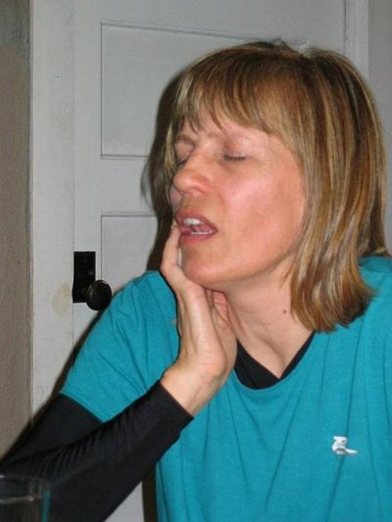

We christen thee MUTTON HONEY (as if she really cared)!!!

ON ON!!!

Next Hash Date: 7 April 2005 (Spring Forward Hash – wear a spring or a clock)
Next Hash Hare(s): Nothing’s Hung Like A Deere (Really, now!)

