SH₃ Hash Trash

Vol. 3, No. 5 Hash No. 28
Hash Date: 5 May 2005
Scribe: Nothing’s Hung Like A Deere
Hare(s): RSAC & Padre VLA
Note: Pictures at the BOTTOM!

When a hash is prefaced with a warning about rattlesnakes you know it will be memorable. Even though we were a bit disappointed to have no snake bites and only ran around 5 miles, the Cinco de Mayo Wilderness Hash was quite a success.

When Padre VLA and Rapid Shitty Anal Cyst hare a hash you better check your bitching at the door and prepare for a long, scenic trail. Now we can add a few more things to expect for their future offerings. The aforementioned rattlesnake warnings, improvised hash marks (eco-friendly though!), bizarre insects, and surprise gifts of liquor. We especially like that last one, boys, make it a habit…

I’m getting ahead of myself, let me start at the beginning. All 11 of us met at the brewpub, if you count the stragglers showing up before and after the hares left in their cars. Fortunately, we had good reason to wait; Gritty Gash made a virgin come! That meant Virgin Will was introduced to Nothing’s Hung Like A Deere, Second Hand Dyke, C Major Ass, Virtual Clinton, Premature Extrapolation, Dildo Baggins, and the long lost but not forgotten Donkey Show Barbie!! Apparently she left the country shortly after getting named but that’s no excuse. With the nine of us hounds giving the hares a hefty 20 minute start we piled into Virtual’s Party Wagon and headed off the start of the trail at Box Canyon. Prior to leaving, though, we were given a handy flyer describing what to expect for trail marks that evening. Everyone was curious about the “Finders Keepers” mark but nobody was more curious than Virgin Will, who had the basics explained to him by those in the back of the van. Not those basics, I mean hashing basics. Pity him, nonetheless.

After arriving at the canyon and noticing some climbers using ropes (How pathetic! Use beer, not ropes!) we headed off through the slot canyon, traversing loose sand and looser rocks. The funny thing was that we followed flour! So much for the little ribbons of different colors we were expecting. However, we shortly began to see them intermingled with the flour marks. As we continued down the canyon we abruptly hit a check that eventually carried us along the road back towards home. After following this for a bit the pack began to spread out, separating the FRB’s from the DFL’s. Fortunately, the trail curved back into the wilderness and hit another check, allowing C Major, Secondhand, and, ahem, Nothing, to catch up. Pretty soon, thanks to Preemo Extrapo’s quick scouting, we scurried off – getting thirstier by the minute. The trail continued up and up, shiggier and shiggier, as the pack began to climb the side of the large outcroppings that frame the Box area. The effort was not fruitless, though, as cries of Beer Near! Went up and the pack began to straggle in. What lay before us but a fine area of sherpa-lugged chips, salsa, beer (Mexican of course!) and water. Everyone was feeling pretty groovy when the boys head off to lay more trail whil we tried to think of songs to sing.

After packing things up in order to hide the coolers from scurvy climbers the pack only traveled a bit before reaching the one Turkey-Eagle split of the night. With all but Donkiest of the women and the one virgin taking the Turkey, the story splits here at this point to follow the loftier pursuit of the Eagle route. It turns out, though, that despite being shorter the Turkey made up for it in skree. The Eagle was most definitely longer - after all, this is the patented Padre VLA-RSAC hash! Anything with less than a 5k between BN’s would seem like cheating.

The Eagle was also simple; the simpletons followed it up and over two ridges before descending down in a canyon that was home to a thoughtfully left first aid kit and a check. After spying the correct way we were off up and through the canyon and over yet another ridge before reaching the main road back towards the Box. At this point, with tired feet from dodged rocks, the road was a welcome respite. Unfortunately, the hares most of known this and suddenly veered off back into the bushes and shaggy. Just when things were beginning to look down we perked up at the sound of the FRBers from both routes shouting about the next (and final) Beer Near.

Upon arriving at the BN we found the spread was the same, which is good for the middle of nowhere! We discussed the trail and flora seen when it was asked (by the hares) if anyone found something. Nobody ‘fessed up until Premature Extrapolation held a little bottle of some mighty fine tequila he had picked up on the Eagle route. The Turkeys felt like real birds for missing theirs but the hares suddenly had reason to hurry back the next morning to clean the trail. Bravo hares! First free beer on hashes, now free liquor! What will they think of next??? Actually… let’s not go there.

After viewing some local insect oddities we all packed up and headed back to the vehicles and drove On In. When arriving at the Pub we got the usual looks and quickly settled down to business – ordering food and starting religion! Nothing was originally nominated to do religion but failed so quickly (and had no voice) that Virtual Clinton took over and did a fine job.

The hares were roasted and Virgin Will learned the meaning of how to complain despite a few attempts at actually giving positive feedback. What do you expect? This was his first time! We naturally concluded giving the hares a down-down with a rousing chorus of Shiggy Trail. The Virgin was next up, along with Gritty Gash, and was promptly down-downed with a Why Were They born So Beautiful. Subsequently, and this took a while, Crimes on trail were announced and practically everybody stood up and took their punishment to the tune of Who Put The Suck In Socorro. Using wanker names, pathetic outfits for a Cinco de Mayo hash, shortcutting, you name it and it was punished.

Somewhere along this timeframe we tried, unsuccessfully, to look for the Hash Hit around the pub and our food began to arrive. Without announcing who would hare the next ‘un, I (Nothing) led us in a fairly accurate Hasher’s Prayer. Just so everyone can help next time, here goes our version:

The Beer's Prayer
Our lager, Which art in barrels,
Hallowed be thy drink.
Thy will be drunk, (I will be drunk),
At home, as it is in the pub.
Give us this day our foamy head,
And forgive us our spillage's,
As we forgive those who spill against us.
And lead us not to incarceration,
But deliver us to inebriation.
For thine is the beer, the bitter and the lager.
Barmen.

With that, we ate and decreed that everyone MUST learn a new hash song before the we meet again.

ON ON!

Next Hash Date: 2 June 2005 (Father’s Day Hash – wear something inappropriately related)

Next Hash Hare(s): Virtual Clinton & Donkey Show Barbie
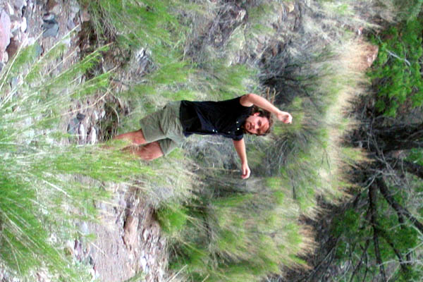

Dildo Baggins (he actually wore shoes!) vibrating around
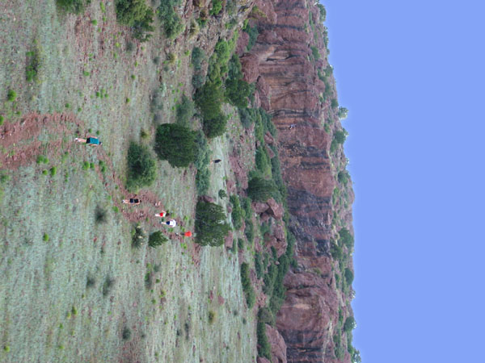

The pack getting thirsty prior to the first BN
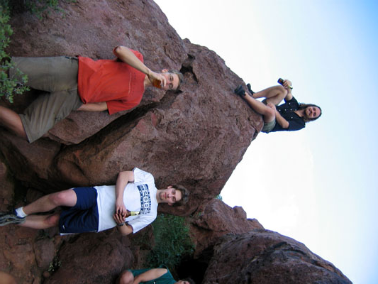

Premature Extrapolation, Dildo Baggins, and Virgin Will enjoy some fine Mexican nectar.
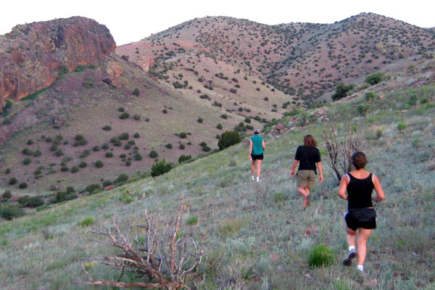

Brave Eagles heading off into the horizon…

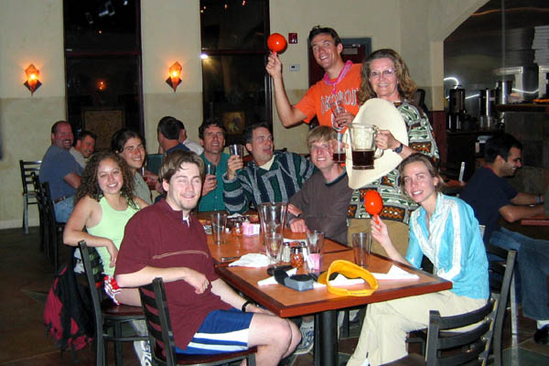

Meanwhile, back at the brewpub…

