SH₃ Hash Trash

Vol. 3, No. 7 Hash No. 30
Hash Date: 7 July 2005
Scribe: Nuclear Semen
Hare(s): Padre VLAAA & Gritty Gash

Well, I wouldn’t have believed it - except that I was THERE! A record turnout for a Socorro hash and only two (yes, TWO!) were from out of town. Twenty-one (21) adventurous souls gathered at the local pub on a warm summer evening (haven’t had many that were not warm) to match wits with a cagy pair of hares – Padre VLAAAA and Gritty Gash (a “virgin” hare). (TWENTY-ONE!!!… Wow!) Present were yours truly, Nuclear Semen (sporting a very patriotic outfit – remember… 4th of July Hash!); Virtual Clinton (in stripes?… well, they were red, white, and blue); Rapid Shitty Anal Cyst (RSAC) (going Hawaiian!); Dildo Baggins (almost unrecognizable with short hair and a goatee!… wearing something that looked like “shoes”); Nothing’s Hung Like A Deere (technology at the ready to record every crime); Second Hand Dyke (actually PRESENT this time for her virgins!!); C Major Ass (in a “T” shirt?!?); Seven Inches Shy (becoming a regular, again!); T.B. (our “chastised-for-her-name” compatriot whose name we won’t spell out); Mutton Honey; Padre VLAAAA (Hare 1); and Gritty Gash (Hare 2) (whew!… hard to remember THIS MANY hash names!!!). In addition, making a return appearance, were Just Pat (says he won’t drink so much this time… Sure!); Just Kathy (with a virgin!); and Just Jayme (also, with a virgin in tow!). And rounding out the pack were SIX (this must be heaven!) virgins – Lorelei (hailing from Austin TX); Fran (finally coming out, eh??); Dingo (don’t get enough “R”’ing otherwise?); Willa & Stefanie (the Bobbsy Twins!); and Jen (another “flatlander” from way back there… the “East” as it’s sometimes known!). (TWENTY-ONE hashers… where did they all come from???)
The gang gathered for a pre-hash brew while waiting for Gritty Gash (Hare 2) to arrive on the scene. Upon her arrival, a fifteen-minute countdown was begun and the hares headed off to lay trail. Meanwhile, the pack indulged in some more brews before heading out front for a chalk talk given by Virtual Clinton. With the preliminaries out of the way (and fifteen minutes passed), the pack headed off in search of trail.

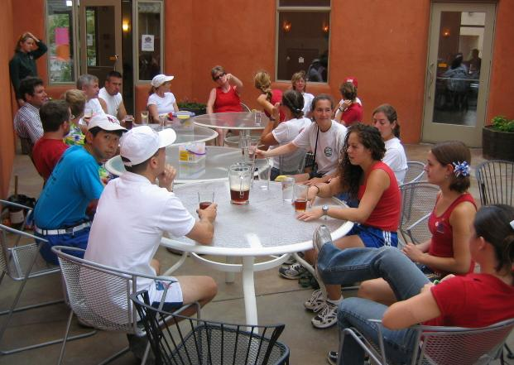

M Mounters doing hash prep. The waitress looks a bit dismayed, though!

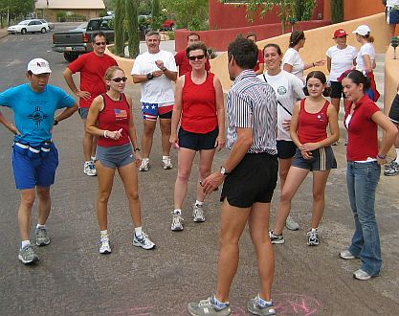

Pack gathered around Virtual Clinton for chalk talk. Some people weren’t paying attention (C Major!).
True trail headed east through the brewpub parking lot and then south to the Pizza Hut. At the Pizza Hut, the trail headed west (yes, folks… couldn’t be a Socorro hash without one) across California Street and towards New Mexico Tech on Campus. At El Camino Real, a check sent the FRB’s searching with true trail being found heading south on the ditch bank. A short detour took the pack through the playground at Zimmerly Elementary School where everyone got to try some of the equipment. Fortunately, for all those with bare legs, the Sun was far enough down so that the slides didn’t burn the skin off.

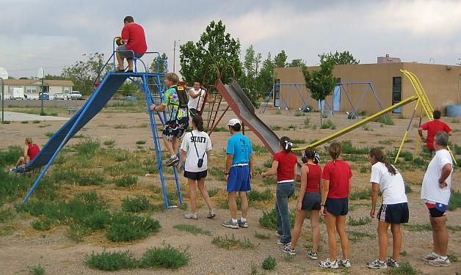

Slides, anyone???

After recess, the pack followed true trail to San Miguel Church, where a pack check was encountered (someone really wanted us to get in trouble with the person “upstairs” – with evidence to prove it!). Thank goodness no one broke into song. Continuing on south towards the Plaza, a check on the corner scattered the pack. Eventually, true trail was discovered heading west on School of Mines, around behind SEI, and to the first BN of the night. It was there that Donkey Show Barbie (better late than never!) joined the pack. Water and ale, along with some munchies, were present (as well as the hares). Everyone took the opportunity to refresh themselves (some even used the bathroom!).

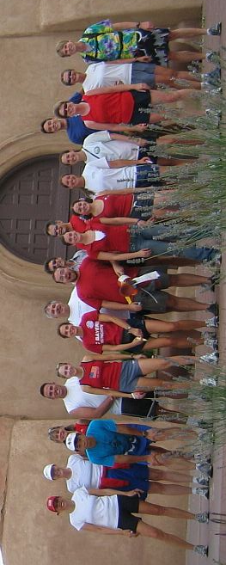
Now were gonna’ get it!!

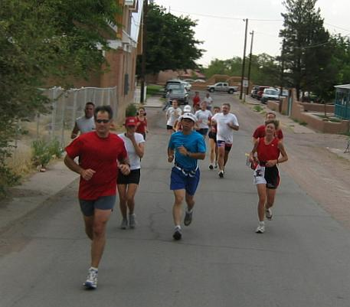

Where’s the beer? We’ve been running far too long!

Too soon, it was time to press on. The hares were given a ten-minute head start while the pack downed their beverages. Papa Don’t Preach (MAJOR SLACKER!!!) stopped by on his way home, claiming that Gritty Gash “told him off” when he attempted to correct her trail marking (it’s not nice to piss off the Papa!!… he co-“sired” this Hash group, remember!). With information about the hares (and ten minutes having passed), the pack headed off towards the Plaza. True trail then headed east on Manzanares, crossing (yes, for a second time!) California Street.

HEY, DID I MENTION THAT THERE WERE 22 HASHERS!!!!!!

A pack check was found in the Valverde Hotel courtyard. The pack gathered in front of the fountain while Nothing balanced his camera on the gate so as to include himself in the picture.

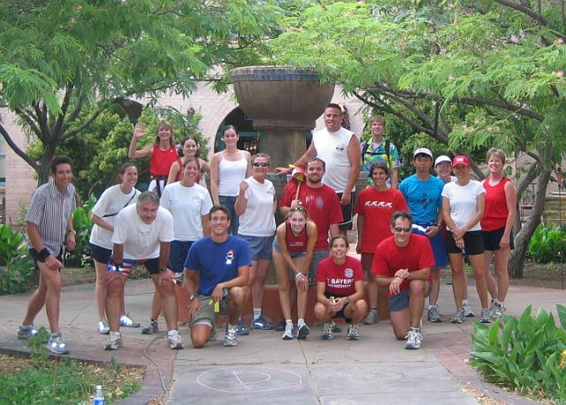

There wasn’t enough room to go skinny-dipping – RATS!!!

True trail headed north from the Valverde and then east under I-25. Just past Rak’s the trail headed north again, taking a left towards the west through someone’s yard. Coming to a ditch, true trail turned north and followed the trail to a turkey/eagle split. The turkeys continued north along the ditch until it linked up with the eagle trail and turned west into a trailer park. The eagles, meantime headed east to the railroad tracks, then followed the true trail north along the tracks. The eagle trail then turned west back to the ditch, joining back up with the turkeys. The final BN of the evening was found in the trailer park.

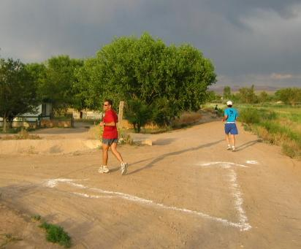

Let’s see… am I an Eagle or a Turkey????

ON IN was declared and the group gathered themselves and headed back to the brewpub. Back at the brewpub, Virtual took charge of Religion (after some refreshments were ordered, of course!). The invocation was led by Nothing and soon after the hash was trashed! First the virgins (SIX!!… count them!), and those who made them come, were called to down-down [Virgins Lorelei & Dingo (Second Hand & Nothing); Virgin Fran (Just Kathy); Virgins Stefanie & Willa (Gritty Gash); and Virgin Jen (Just Jayme)]. Now, they are “Justified.” Next, the hares were called forward. A whole litany of complaints greeted them, including “too short an eagle leg,” “the playground sucked,” and “not enough railroad ties, pack checks, fireworks….” With that (and a chorus of Shitty Trail), the hares redeemed themselves with a good down-down. Second Hand and Gritty Gash were assessed down-downs for failing to be present at the last hash when someone had “come” for them (Just Pat, then a virgin, and Strawberry Shortdick from El Paso). Crimes-on-trail down-downs were given to almost everyone (except Virtual… hmmm… leading Religion does not make you immune!) for “T” or “R” shirts, etc., including Gritty Gash’s “run in” with Papa. FRB down-downs were given to Just Dingo, RSAC, Virtual (about time!), and Nothing (it doesn’t pay to go fast!). RSAC got the blood-on-trail nod (what was it that got you???).

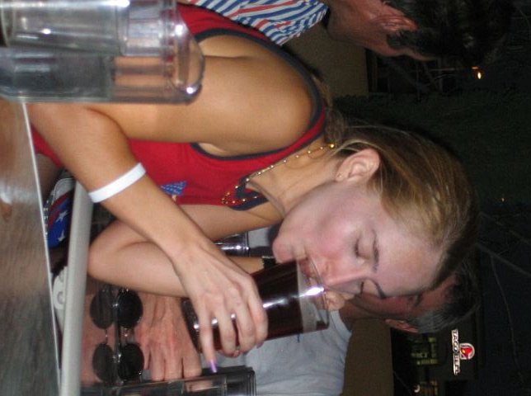

Virgin Lorelei getting primed for Religion!

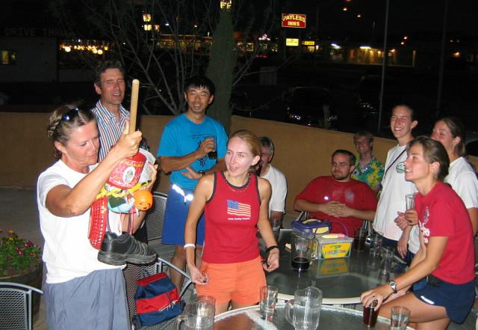

C Major Ass leading the group in song (well, she does teach music!).

Added to the agenda (after many secret discussions), was the renaming of TB. After renaming her back when (reference Hash No. 24), TB’s hash name had become a source of familial friction. Thus, rather than lose her, it was decided to rename her. Some of the names that were offered up were Twiggy Thatch, Maude Flanders, and 80 Pound Weakling. But in the end, it was TWIGGY FLANDERS that was the clear winner (the pack had spoken!). From this hash forward TB will now be known as Twiggy Flanders!
Religion was concluded and plans were made for the next hash. Second Hand Dyke and Just Pat volunteered to co-hare the hash to take place on 4 August (same time, same place). The theme selected was “Back to School.” Wear your best “Back to School” outfit.

ON ON!!!

Next Hash Date: 4 August 2005 (Back to School Hash – be a nerd!)
Next Hash Hare(s): Second Hand Dyke & Just Pat

