SH₃ Hash Trash

Vol. 3, No. 9 Hash No. 32
Hash Date: 1 September 2005
Scribe: Nuclear Semen
Hare(s): Nothing’s Hung Like A Deere & Wet And Hairy Banana Fairy

Well, at least I got this out before the next hash!!!

Wow, it’s still hard to believe that eighteen hashers showed up at the local brewpub for the Labor (not the kind celebrated by the holiday!) Day Hash. The guys appeared to take the theme more seriously than the ladies (I guess that’s because guys DON’T HAVE A CLUE as to what a woman goes through during labor!!). Present were yours truly, Nuclear Semen (from the ranks of the clueless); Virtual Clinton (a mommy wanna-be!); Padre VLAAA (another mommy wanna-be!); Rapid Shitty Anal Cyst (RSAC) (at his LAST Socorro hash… at least for a while!); Second Hand Dyke (baby in tow… and I don’t mean Nothing); Nothing’s Hung Like A Deere (one of our illustrious hares… pushing a “flour” child in a stroller); Dildo Baggins (a real “newborn”… almost makes you think twice… but babies do clean up nice!); Gritty Gash; Mutton Honey; Wet And Hairy Banana Fairy (our other illustrious hare!); MacHaggis Hole (anybody remember this guy????); and Twiggy Flanders. Also on hand were Just Shasta (with child); Just Dingo (also his LAST hash in Socorro!); Just Pat; and Just Jayme (with a virgin in tow!). Rounding out the cast were Virgin Clayton (Just Jayme’s “boy toy”!) and Virgin Tsama (coming for MacHaggis!).
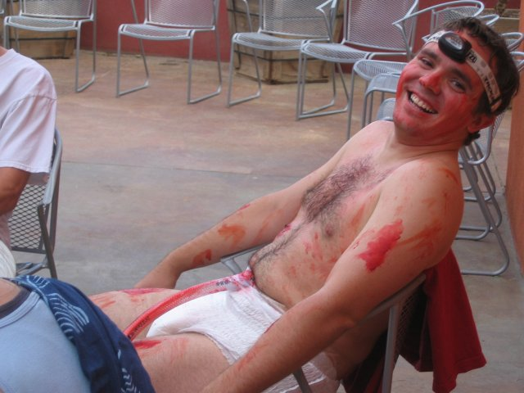

“Newborn” Dildo (doesn’t look much different than the grown-up Dildo!)
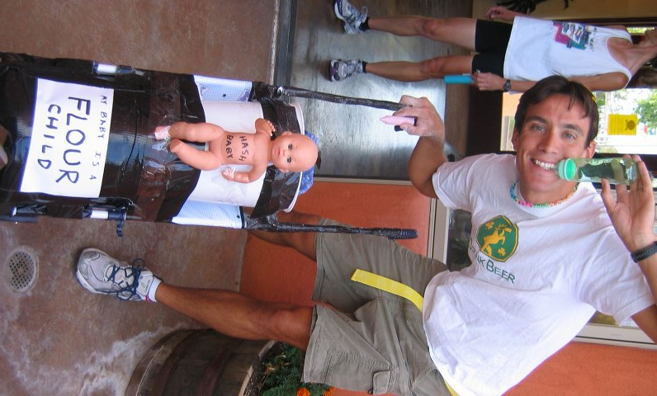

Ahhh… the proud “Papa”!!!

After the usual introductions (where all the virgins become really confused as to who everyone is!) and some “brewski” (which probably doesn’t help the virgins remember names any better), Hares Nothing and Wet And Hairy headed off with a fifteen-minute head start. At the appointed time (as if it really mattered), the pack headed out for the chalk talk given by Virtual. Then, the pack headed off in search of true trail.
After a check of all the possible leads from the first check, true trail was found, heading east behind the brewpub and turning south towards WalMart. After a second check, the trail headed into the WalMart parking lot to a pack check in front of the store.

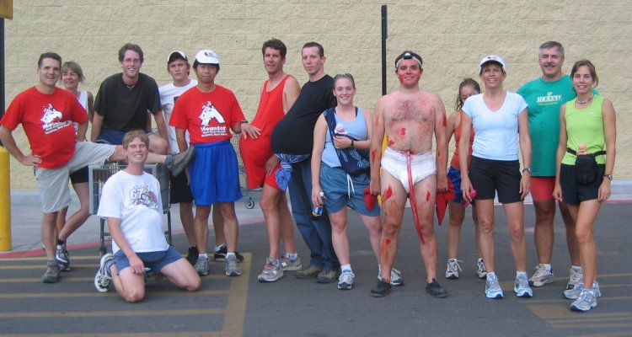
The Mamas and the Papas (and babies, too)!

True trail continued south to Otero and then turned east and under I-25. Then the trail took the frontage road to the south and into the “BIRTH CANAL” (the infamous culvert!). Thanks to the weather, the pack encountered plenty of shiggy in the culvert, making for a rather uncomfortable passage (at least for those of us over five feet tall!!!). Only Dildo managed to incur “blood on trail” for the journey, though it was really hard to differentiate it from the “fake” blood! If the “Canal” hadn’t been demanding enough, the pack soon arrived at a turkey-eagle split. The “turkey” trail headed to First State Bank, west across (your first two guesses don’t count) California Street (what would a Socorro hash be without at least one crossing!), and south at the Plaza to the first BN at the Capitol Bar. Meanwhile, the eagles (stupid fools… or real masochists!) headed south to Clark Field and then west across California Street to the county jail. From there the “eagle” trail headed north to the plaza and to the first BN of the evening.
Beer was ordered and the hounds milled about the courtyard trying to rid themselves of the shiggy still clinging tenaciously to anything that had touched it. The restroom sink looked Tech’s mud bog!! The floor was even worse!!!! With Charlie and the Chocolate Factory fresh on everyone’s mind, Dildo regaled the group with his rendition of Pure Inebriation (sorry, Mr. Dahl)! Just Jayme was about to commit “alcohol abuse” until rescued by Nuclear (NOTE: You still owe me for that, Missy!!!). With the pack ailing, the hares exited with a five-minute head start.

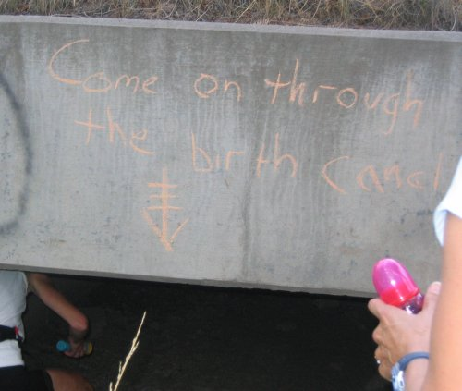

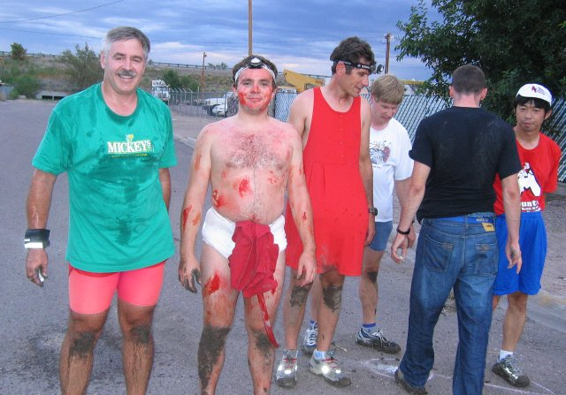
An “experience” best forgotten!

Lest we forget what real shiggy is!!!
Reluctantly, after five minutes, the pack headed off in search of true trail. True trail was quickly found, heading north towards the San Miguel Mission. After the church, it then abruptly cut over to School of Mines and a check mark. True trail was found to head over to Neal Avenue, where another pack check was discovered in front of the Bhasker Clinic.
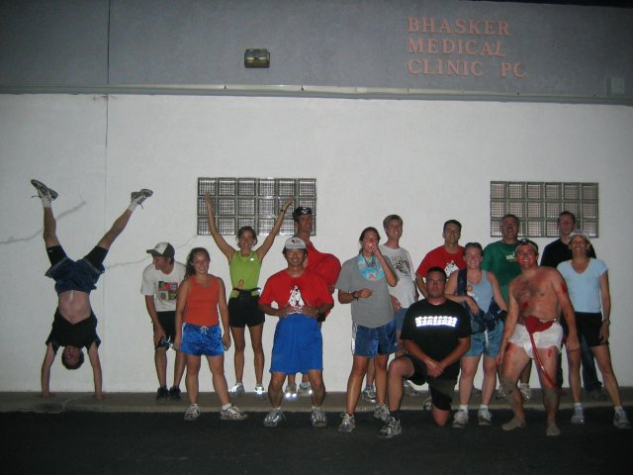
Hey, kids, it’s ten o’clock. Do you know where your parents are!!

Not much further, the pack encountered a second turkey-eagle split (two in one hash… the hares must be sadists!!!) at Franklin Street. The “turkey” trail headed over to and west on School of Mines, then cut over to Fitch Street. Continuing west on Fitch, true trail again cut south to Neal Avenue. Following Neal west the trail headed up the hill around New Mexico Tech and through Altamirano Hall (the new dorm). After making it through Altamirano Hall, true trail headed over to South Hall, to the second floor, past another party (did anyone stop there??), and down the north end stairs. Then the trail headed east to Leroy where it turned south. At the first alley on the left, true trail headed west to the second BN of the evening in Virtual’s backyard. The eagles, meanwhile, followed their trail through Western Hill and around to Goad, where they headed north and picked up the “turkey” trail at the intersection of Neal and Leroy.
On-In was declared, but not before RSAC debuted his “for-M-Mounters-only” song. We extend our thanks to RSAC for also e-mailing the lyrics to everyone (now we have several “Socorro Songs”!!!).
Back at the Socorro Springs Brewery, SH₃ engaged in Religion, led by Virtual Clinton in the absence of Nuclear Semen. The usual raucous debauchery ensued (when are they going to kick us out?) with the familiar litany of crimes and fines. A hearty farewell was given to departing hashers RSAC and Just Dingo. Plans were laid for the October hash scheduled for the 6th. A pick-up hash was chosen – everyone come prepared to hare (even if you don’t know what to do!!… we’ll show you!). Also note that, if present at the next hash, it would be Just Jayme’s FIFTH hash (WHO HAS THE NAMING HAT?).
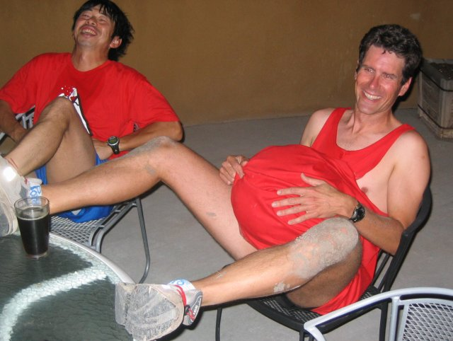

Virtual soon to have a “bouncing” baby!

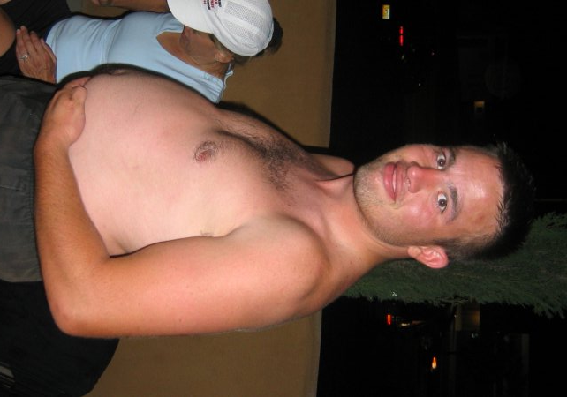

It looks real, Just Pat (are we sure you’re a guy?)!

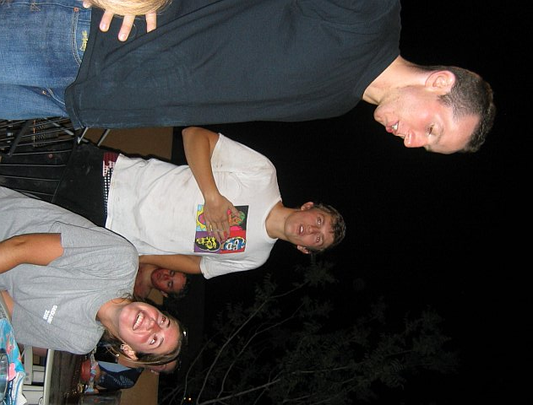

September Virgins Clayton and Tsama (look at Just Jayme smile at having made one of them “come”)!

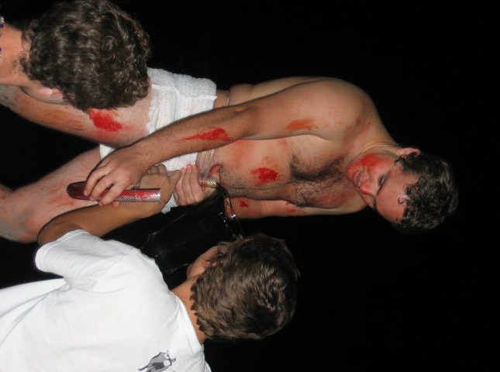

Okay… this is gross!!!!!

ON ON!!!

Next Hash Date: 6 October 2005 (Pick-Up Hash!)
Next Hash Hare(s): EVERYBODY!!!

