SH₃ Hash Trash

Vol. 4, No. 2 Hash No. 38
Hash Date: 9 February 2006
Scribe: Virtual Clinton (kinda)
Hare(s): Just Seth (hare wannabe) and Virtual Clinton

If it’s February, it must be the annual Valentine’s Day hash, which is never, by tradition, held on St. Valentine’s Day. So all of Socorro’s hardcore hashers pinned a heart-on their shirt (or whatever) and headed down to the El Matador for a night of debauchery. The usual crowd showed up - let’s see, Papa was absent as usual (being a real life Papa three times over must have worn him out), Nothing and Second Hand were missing, as was Nuclear (something about working late…?). Hmm… come to think of it, the only old hand was Virtual (“singlehood” has its advantages… having nothing better to do on a Thursday seems to be one of them). But that was OK, there was a newbie hare; Just Seth had volunteered to lead us after only his second hash. And there was a good showing from the newer hashers. Alcatramp, Dildo Baggins, Just Shasta, Just Ligia, Just Colin, and Just Chama showed up. MacHaggis Hole dropped in, wearing a pink dress for the occasion (hadn’t seen him in a while). And to everyone’s surprise, after announcing his departure at the previous hash, Giggles returned for one more hash (muttered something about a court date… we didn’t press for details).

So the beer was poured and dispatched and the night progressed. But where was our hare? Just Seth persisted in his absence well into the appointed hour. At last, Virtual was appointed “ad-hoc hare” by no one in particular and pushed rather unwillingly out the door. After the appropriate time, the hashers started off, following the trail that led first north on California Street, veering to the front of Smith’s, and then turned west to Camino Real. The trail wandered south and west again, through some mild shiggy to Bullock, past the domicile of out absent scribe, and crossed School of Mines to the first Beer Near at Virtual’s pad. No really, I mean it, there was a real Beer Near at Virtual’s place, with beer and goodies and all. The wonder is that the hashers took it seriously; they’ve been fooled there before more than once.

Or something like that happened! I laid the trail and I don’t have a good grasp of what happened that night. Even the pictures look kind of hazy…

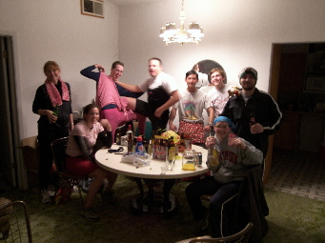

The pack shows off their beers!

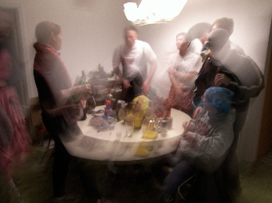

The party (and the drinking) continue…

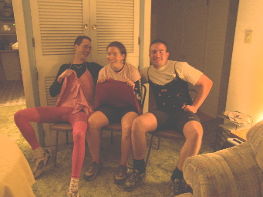

Did we really need to see this?

When Giggles discovered the tequila and announced that it usually made his clothes come off, the hare made his escape. Whatever happened in his house after his departure will forever be unknown to him (and he prefers it that way!). Eventually, the pack followed the trail, which led them onto the Tech campus and a tour of the third story of the student apartments and then back south on Leroy to Nothing and Second Hand’s place. The pack was instructed to sing to Nothing then follow the trail east on Hannah to Papa’s place. After singing to Papa, the pack continued east on Neel, to the ditch behind the charter school, back to Neel and then down Fisher to the Plaza and finally to the last Beer Near at the Cap. Since there was no band on a Thursday, the pack took over the side room.

One might believe that, alcohol intake notwithstanding, after a brisk run on a cold February night, all would arrive at the last beer stop with clear heads. But… one would be wrong! It seems that Just Colin’s birthday was that very night. Just Ligia had prepared a cake, which had been left at the El Matador. Since the El Matador was closing soon, the group decided to hold up in the Cap and send out a scout for the cake. Virtual volunteered to fetch the cake when Giggles walked in. He immediately volunteered to help out; he said he was very good at moving cakes. He was told that it wasn’t necessary but he insisted; so, Virtual and Giggles headed out into the night to get the cake. Only when the cake was brought from behind the bar did Giggles catch on that we were talking about cake (he thought we were bringing a keg to the Cap) (Keg… cake… they sound alike!). On the way back, we ordered some pizza.
Now the rest of the evening is a bit of a blur. We had religion (of a sort). Giggles was given a down-down just because and more down-downs for various reasons. Other hashers received them for wanker names, cutting the trail, and lack of heart-ons. After religion was over and the pizza was largely gone, Just Colin’s birthday was celebrated. First, he blew out a few candles. Then we ate some cake. Then we threatened each other with the rest of the cake. Soon there were pieces of cake flying through the air. At last, the cake remains were strewn on the floor. Occasionally, the bartender would peek in, but Giggles is a familiar sight at the Cap and she would just shake her head and leave. Alas, some, including this scribe, being forced by their employers to at least show up for work on Friday, had to bid farewell. So the depths (of depravity) reached by this little party remain undocumented! Let’s say that a good time was had by all and leave it at that.

ON ON!!!

Next Hash Date: 9 March 2006 (St. Patrick’s Day Hash… Erin Go Bragh!! Better be wearin’ green!)
Next Hash Hare(s): TBD

